**INTERNSHIP ON CYBER SECURITY**

**INTRODUCTION:**

My name is Amisha S Shetty. I’m an Information Science student from Mangalore Institute of Technology & Engineering, Moodbidre. Currently I’m studying in 8th semester. This internship was a great opportunity to learn about Cyber Security. Below here, is the report of my Cyber Security Internship at Dlithe.

**ABOUT DLITHE:**

DLithe is an EdTech company serving IT Companies and Academic Institutions, since the year 2018. With experiences drawn from corporate time, the foundation of DLithe is built to innovate products that transform the upcoming generation. Our expertise in Embedded Systems, Robotics, Internet of Things, Cyber Security, and Artificial Intelligence is helping academics institutions to align with industry needs. Since inception, it has established 8 development centers enabling student community to work on research and development. Its services to IT companies have reduced the hiring cycle time and led to cost effective measures to source the best talent from on and off campus. Dlithe has transformed many lives by imparting 360 degree learning – Domain, Process & Technology, keeping focus on Customer Experience and Operational Excellence objectives.DLithe is a bootstrap company with strong foundation, experience, trust and commitment to build an agile workforce towards industry need.

**SUMMARY OF INTERNSHIP :**

In this one month internship, we were exposed to various concepts related to Cyber Security. On the first day of internship ,i.e 06-02-2023 , an introduction to Cyber Security was given, in which different types of cyber attacks were explained. Some of them are as follows:

1. Phishing
2. SQL Injection
3. DNS attack
4. Dos/DDos
5. Man-in-the-middle attack
6. Spyware/keylogger

After this, introduction to hacking, various types of hackers and different phases of hacking were explained. Under the types of hackers, there are 5 types , namely ****White hat, Script kiddies, Black hat, Gray hat, Suicide hackers.****White hat hackers are those who uses hacking skills to identify security vulnerabilities in hardware, software or networks. They respect the law and do not commit illegal attacks. Black hat hackers engage in cybercrime operations and uses hacking for financial gain or other malicious motives.

At the end of session ,Phases of Hacking were discussed, as follows:****Reconnaissance****: Gathering information about a target before launching an attack.****Scanning****: Identify a quick way to gain access to the network.****Gaining**** ****access****: Gain access to the system, applications, and network, and control the systems connected to it.****Maintaining**** ****access****: Secure access to the organization’s Rootkits and Trojans and uses it to launch additional attacks.****Clearing the tracks****: After gaining access, cover the tracks to escape the security personnel.

On the second day, we were taught about Networking, types of network, topologies and network devices. Various types of network namely, ****LAN, WAN, MAN, PAN**** were explained in detail. LAN or Local Area Network is a collection of devices connected together in one physical location, such as a building, office, or home while MAN or Metropolitan Area Network is a computer network that connects computers within a metropolitan area, which could be a single large city, multiple cities and towns.

Network Topologies like star topology, bus topology, ring topology, mesh topology, tree topology, ring topology etc were discussed with diagrams. Then the differences between switch, hub and routers were reviewed at the end of session.

## **OSI Model and TCP/IP Model**

Networking models like OSI and TCP/IP were discussed. The layers of model along with their functions were explained in depth. The seven layers of OSI model-

1. Physical Layer: Physical cable or wireless connection between network nodes.
2. Data Link Layer: Establishes and terminates a connection between two physically-connected nodes.
3. Network Layer: Routing packets by discovering the best path across a physical network.
4. Transport Layer: Carries out flow control, sending data at a rate that matches the connection speed of the receiving device, and error control.
5. Session Layer: Creates communication channels, called sessions, between devices.
6. Presentation Layer: Prepares data for the application layer.
7. Application Layer: Used by end-user software such as web browsers and email clients.

****Network devices:****

Network devices like Hub, Modem, Router, Bridge, Switch, Gateway , Repeaters etc were discussed along with their functions. At the end of session we were told to install virtual box and kali linux for practicals.

The continuation of network devices were carried out at the beginning of next session. After which Internet Protocols(IP) like IPv4 and IPv6 were discussed briefly. Different classes of IP like class A, B, C, D, E and its usage were explained. IPv4 address in dotted decimal notation were represented.

After this, checking the certificate viewer of a URL was illustrated and its various parts like validity period, issued by , etc were discussed.

****Components of Cloud Computing:****Clients, Data center, Distributed server are the different components of Cloud Computing. Clients are computers, laptops, mobile phones etc. Data center is collection of servers and has applications. Distributed server is servers distributed in different geographical locations.

Cloud computing technologies:Virtualization allows sharing single physical instance of application among multiple tenants. SOA helps in using applications as a service for other applications. In Grid computing, group of computers are connected with each other from different locations to achieve common goal. Utility computing offers computational resources as a metered service.

## **Service Models:**

* Infrastructure as a service: Iaas provides access to fundamental resources such as virtual machines, virtual storage etc.
* Platform as a service: Paas offers runtime environment for applications and deployment tools required to develop applications.
* Software as a service: Saas offers cloud based applications to be used by the clients by accessing it from any device.

## **Information Security:**

The practice of preventing unauthorized access, usage, modification, etc of information. Objectives of information Security: CIA — Confidentiality, Integrity, Availability.

Common Terms:****Vulnerability****: Flaw or weakness in a system’s design, implementation, or management that could be exploited.****Threat****: Something that harms the assets owned by an application by exploiting a vulnerability.****Risk****: Potential for loss due to vulnerability being exploited by threat.

****Cookies:**** These are small files if information that a web server generates and sends to a web browser.

Different types of cookies:Session cookies,Persistent cookies,Authentication cookies,Tracking cookies

## **ISRM(Information Security Risk Management):**

It is the process of managing risks associated the use of Information Technology. Stages of ISRM are: Identification, Assessment, Communication, Rinse and Repeat.

Cyber Kill Chain Methodology:Reconnaissance: Gathering target information.Weaponization: Collecting exploits and creating payloads.Delivery: Define the way how exploits are delivered into victim.Exploitation: Exploit a vulnerability with a defined exploit or trigger the payload.Installation: Installing backdoor on victim computer.Command and control: Establish two way communication between attacker and victim and perform privilege escalation.Actions on objectives: Perform intended goals.

****Vulnerability Assessment:****Process of defining, identifying, prioritizing vulnerabilities in computer systems, applications and providing necessary awareness to understand threats to environment and react properly.

In the later classes different concepts like cryptography , its types, namely Symmetric key, Asymmetric key, and hash function were explained. Types of ciphers — monoalphabetic cipher, polyalphabetic cipher, caesar cipher, playfair cipher, hill cipher were discussed briefly.

Various algorithms like ****Diffie Hellman key exchange, RSA algorithm,MD5**** were introduced. After this, we were told to install kali linux , metasploitable and windows 7 virtual machines. Practiced basic commands in kali linux like ****ssh, ls, pwd, cd, touch, echo, nano, vim, cat ,**** etc. Google search operators like ‘inurl’, ‘intitle’, etc were taught in-order to search effectively.

Later on, started with network scanning concepts where lots of commands like****ifconfig, nbtscan, nmap,**** etc and its usage were defined. nbtscan is used to detect the target IP and nmap is used to scan the target IP for vulnerabilities. After getting used to the basic concepts, different tasks were assigned.

**TECHNICAL TASKS :**

**PASSWORD CRACKING OF WINDOWS 7 MACHINE**

PwDump7 is used for dumping system passwords. PwDump runs by extracting SAM and SYSTEM File from the File system and then extracting the hashes. A malicious attacker can use this tool to extract credentials from the victim system.PwDump7 can be used as a post-compromise tool; the attacker must have access to the system. Access can be local or remote. To acquire remote access, the attacker may need to exploit a vulnerability in the system.

Steps to crack password of windows 7 machine:

Step 1: Download pwdump7 tool from openwall.com in your machine and extract the zip file.

Step 2: Open terminal in administrator mode and go to downloads->pwdump7.

Step 3: Run the command pwdump7.exe >> hash3.txt to transfer hash values into hash.txt

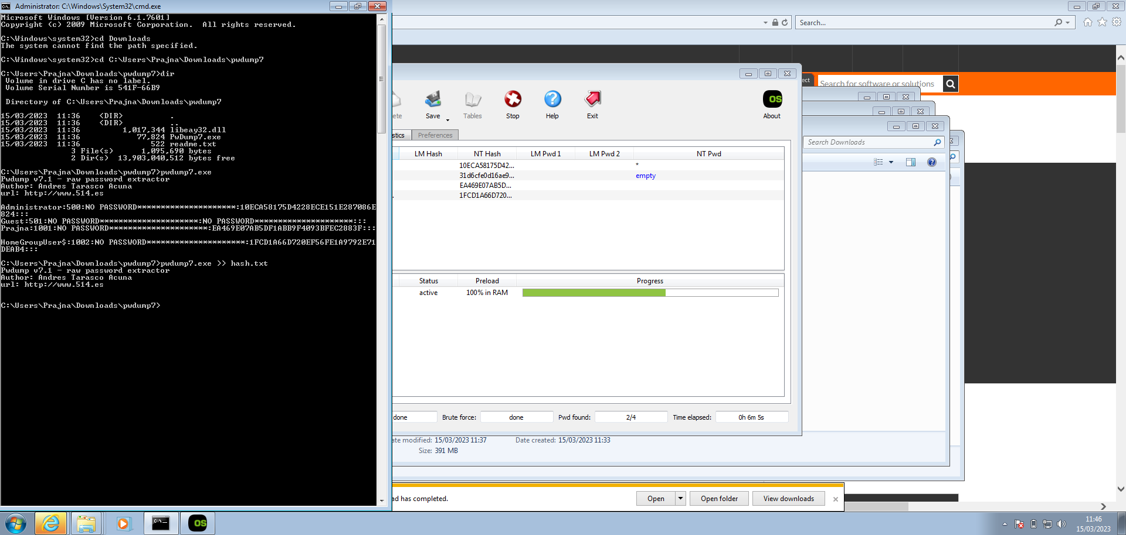

Step 4: Open hash3.txt in notepad to view the hash values.

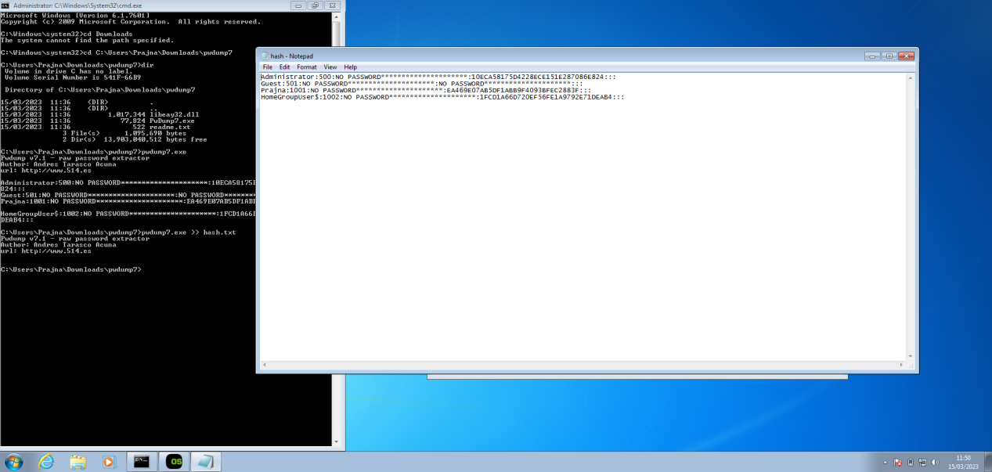

Step 5: Open tmp files.org and upload the hash3.txt file. Open kali linux and in broswer enter the url of hash3.txt.

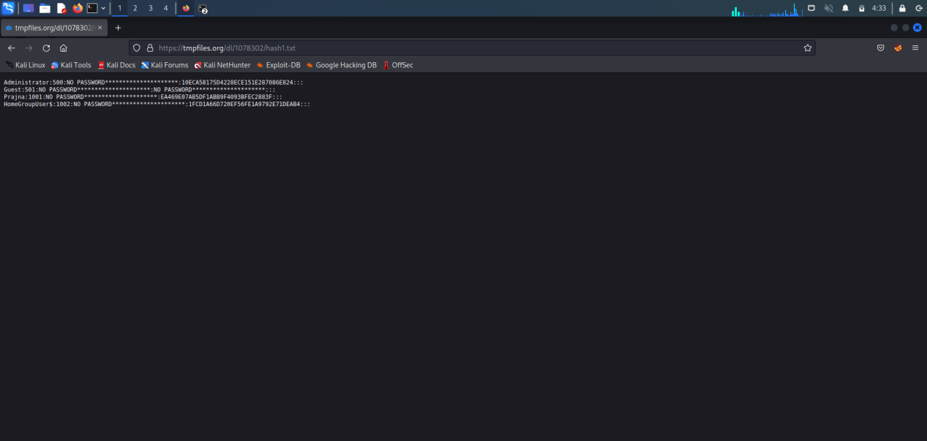

Step 6: Enter command nano hash3.txt and paste the hash contents.

Enter john hash3.txt to decrypt and get the password.

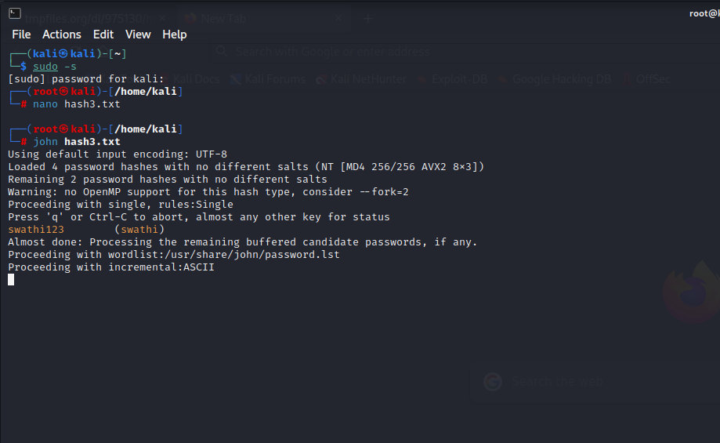

**PASSWORD CRACKING OF METASPLOIT USING HYDRA**

Hydra is a brute-forcing tool that helps penetration testers and ethical hackers crack the passwords of network services.Hydra can perform rapid dictionary attacks against more than 50 protocols. This includes telnet, FTP, HTTP, HTTPS, SMB, databases, and several other services.

Brute force attacks can be successful if the password or key is weak, short, or has been reused across multiple accounts. To prevent brute force attacks, it is important to use strong and unique passwords or passphrases that are difficult to guess or crack.

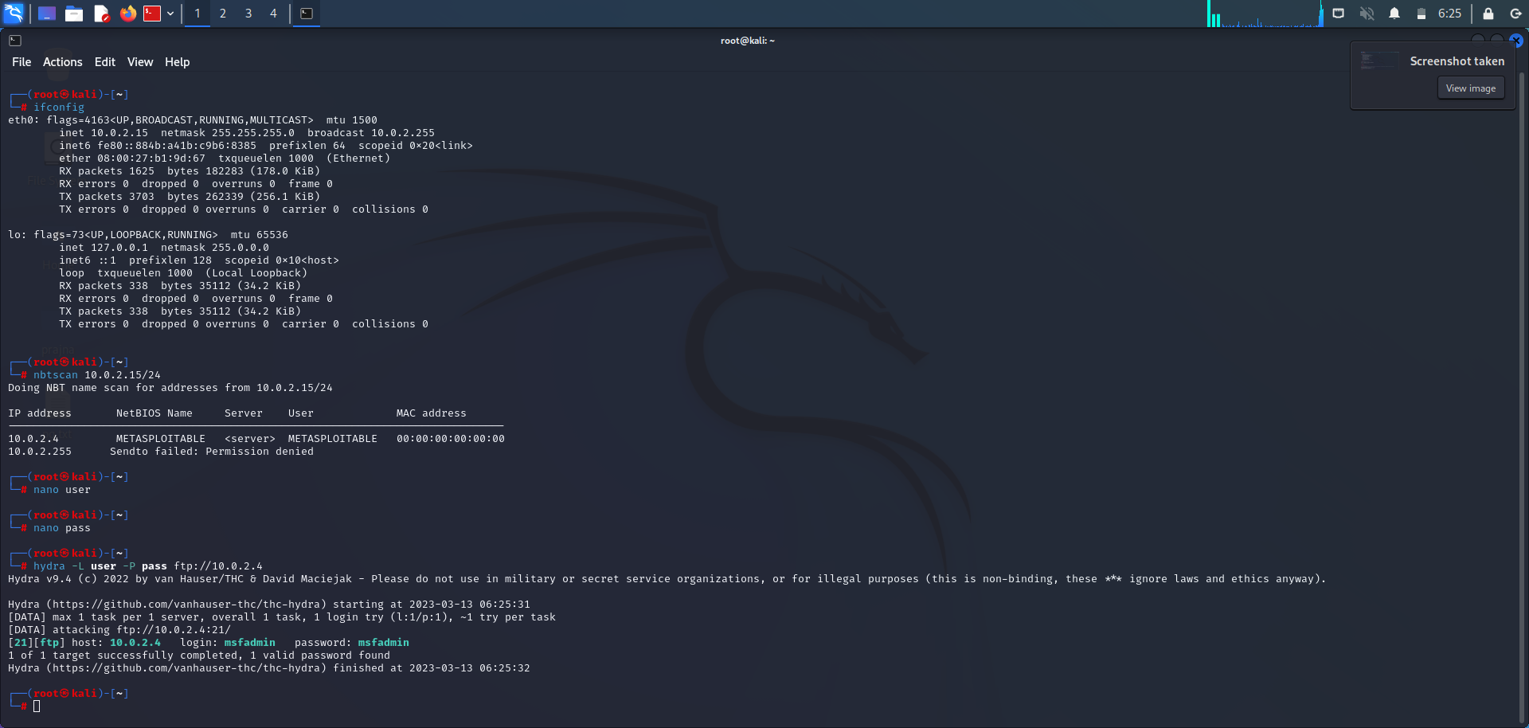

**‘nbtscan’** is a command-line tool used to scan networks for NetBIOS name information. It can be used to identify Windows machines on a network, as well as gather information such as hostnames, MAC addresses, and workgroups.

Nano is a command-line text editor that is available in Kali Linux, Nano is a lightweight text editor that is designed to be easy to use and has a user-friendly interface. It provides basic text editing features such as cut, copy, and paste, as well as search and replace, spell checking, and syntax highlighting for various programming languages.

To open a file using nano in Kali Linux, you can use the command **nano <filename>** in the terminal. Once you have made your edits, you can save the changes and exit the editor by pressing **Ctrl+X**, and then confirming the save changes prompt.

1st create a file named ‘user’ and add the user’s name. Then create another file named ‘pass’ and add the user’s password in to that file. To save the file press Ctrl+S and exit it by Ctrl+X.

The command **hydra -L user -P pass ftp://192.168.56.101** is a sample command for using the Hydra password cracking tool to perform a brute force attack on an FTP server running on the IP address **192.168.56.101**.

* **hydra**: This is the command to invoke the Hydra password cracking tool.
* **-L user**: This option specifies the path to the file containing a list of usernames to use during the attack. In this case, the word "user" is being used as a placeholder for the actual file name or path.
* **-P pass**: This option specifies the path to the file containing a list of passwords to use during the attack. Similarly, the word "pass" is being used as a placeholder for the actual file name or path.
* **ftp://192.168.56.101**: This is the protocol and IP address of the target FTP server.

By this we can perform brute-force attack. At the end we get the username and password of the user.In thus case, the username is msfadmin and the password of metasploit is msfadmin.

**PASSWORD CRACKING OF ONLINE VULNERABLE**

**WEBSITE(testfire.net) USING BURPSUITE**

Burp Suite, by Port Swigger, is a versatile and powerful tool for web app pentesting. Besides web form authentication testing, it can also be used to test for session ID randomization, injection attacks, fuzzing and numerous other attacks.

Password cracking of testfire.net:

Step 1: Open Burp Suite and switch on the intercept.

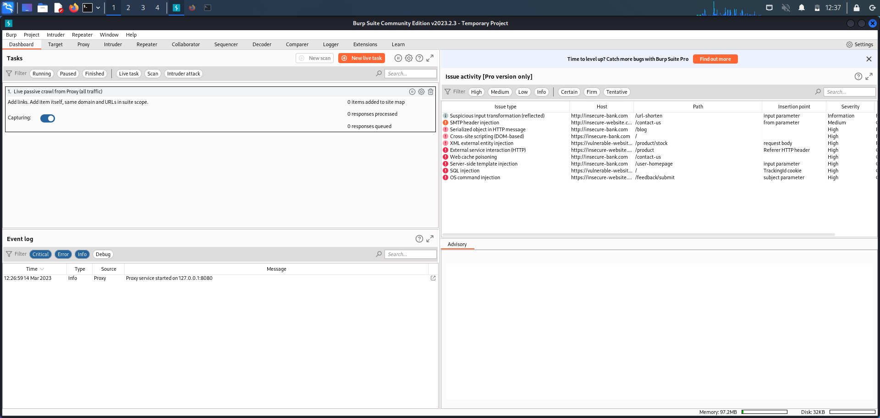

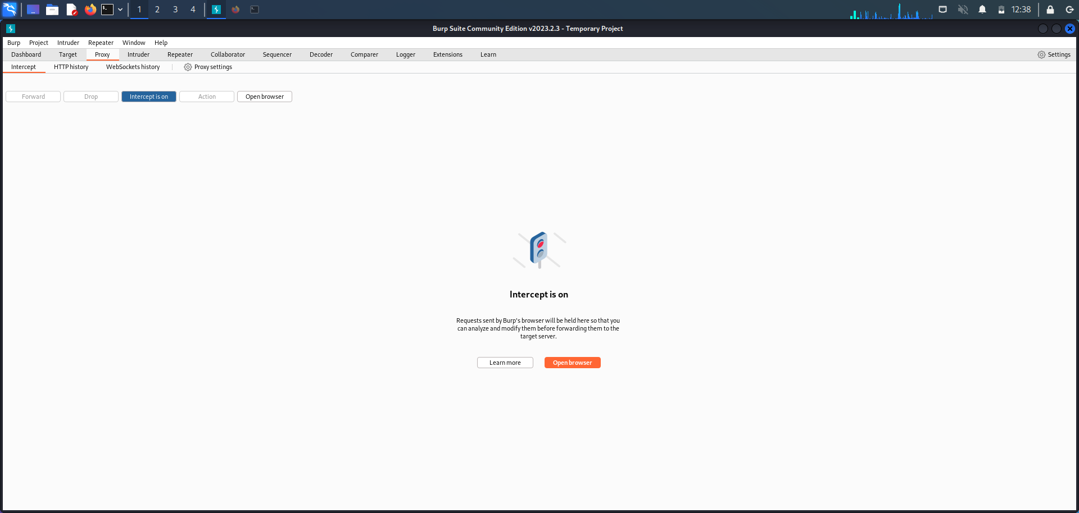

Step 2: Open demo.testfire.net and try to login.

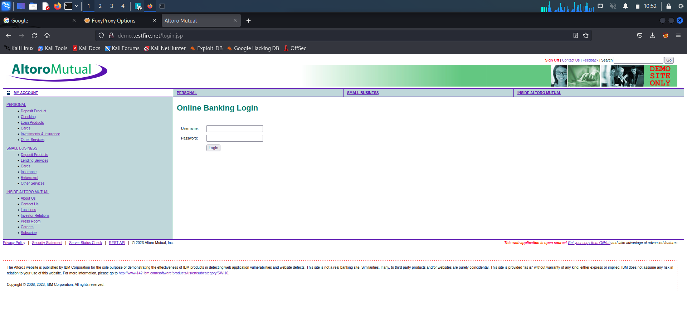

Step 3: Open Burp Suite and go to proxy. Search for “doLogin” and send the host id to the intruder.

In intruder select the payloads for username and password. Select attack type as cluster bomb. In payload options , enter different usernames and passwords. Then start the attack.

Check for change in length. If length changes, then that is the correct username and password.

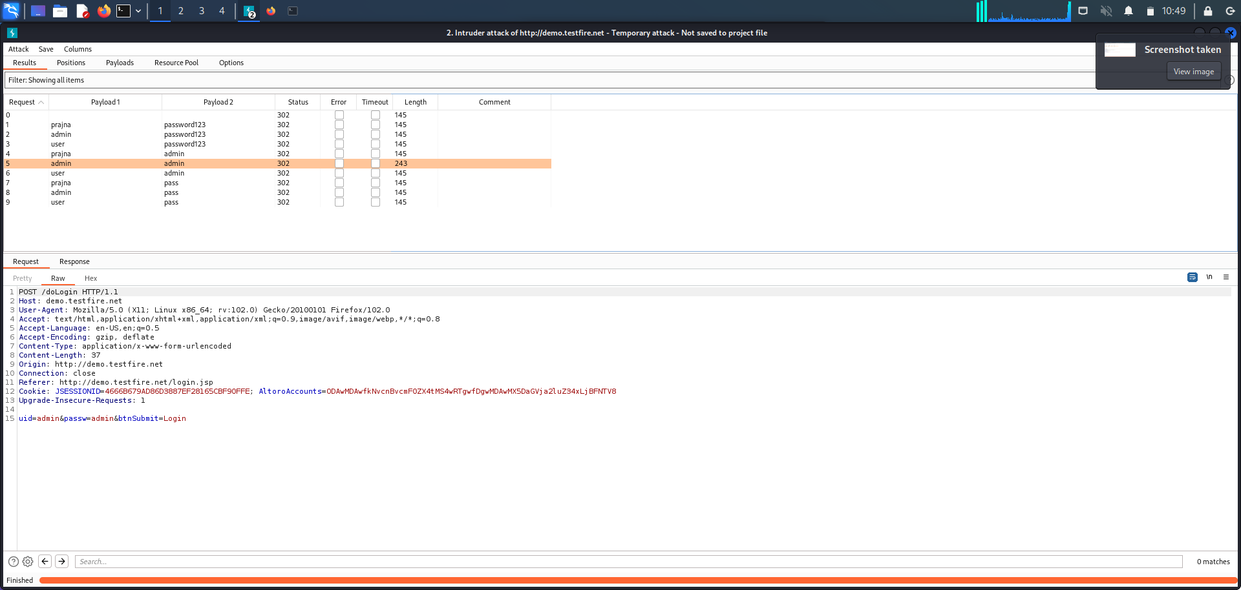

In the above example, username is admin and password is admin. Enter this in testfire.net. By this, the password cracking of online vulnerable website using Burp Suite is successful.

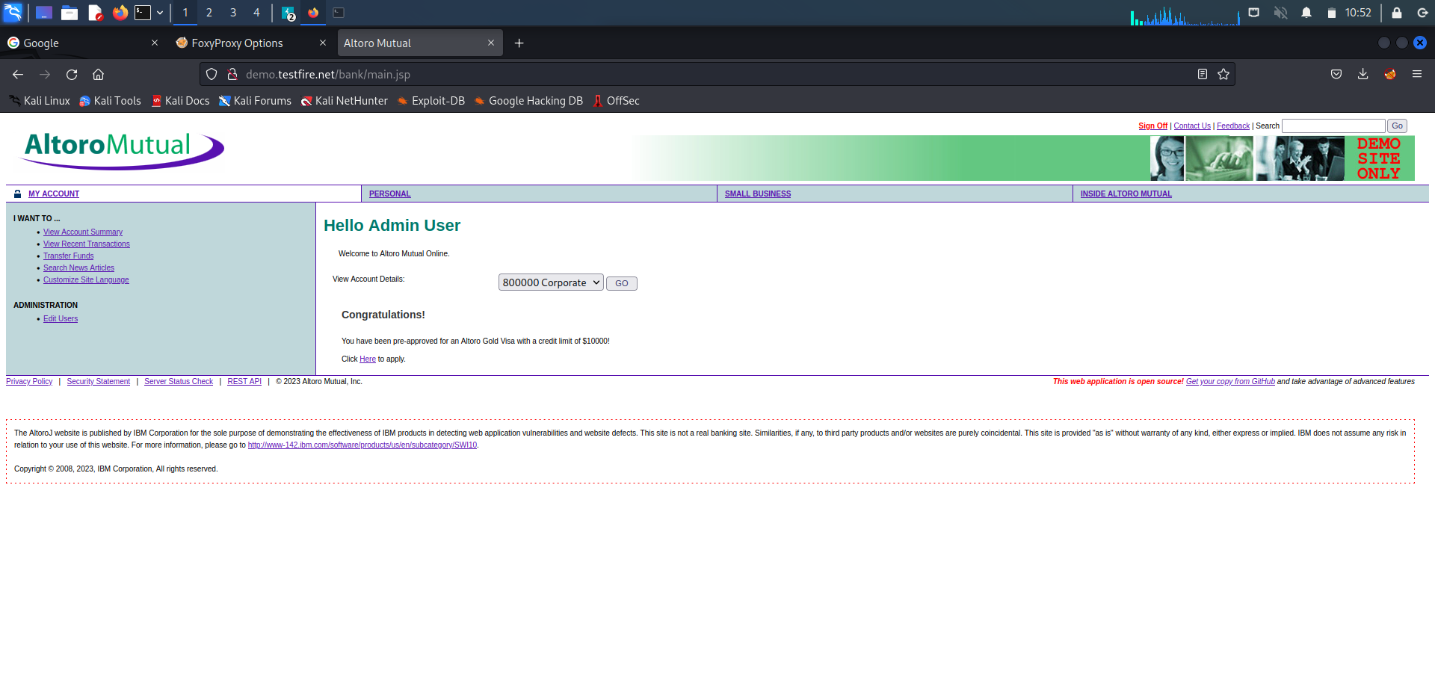

**METASPOITABLE EXPLOITATION**

SMTP stands for Simple Mail Transfer Protocol.SMTP is a set of communication guidelines that allow software to transmit an electronic mail over the internet is called ****Simple Mail Transfer Protocol****.It is a program used for sending messages to other computer users based on e-mail addresses.It provides a mail exchange between users on the same or different computers, and it also supports:

* It can send a single message to one or more recipients.

* Sending message can include text, voice, video or graphics.

* It can also send the messages on networks outside the internet.

**1. SMTP**

Step 1: Getting super access using the command $ sudo -s

Step 2: Check the IP address of the target (Metasploitable)

Step 3: Enter the command nbtscan, it is a program for scanning IP networks for NetBIOS name

information. nbtscan 192.168.56.0/24

Step 4: Enter the command nmap -sV followed by the target IP, nmap is a utility for network exploration

security auditing and -sV for the system versions. nmap -sV 192.168.56.101

Step 5: Enter msfconsole, it is used to provide a command line interface to access and work with the

Metaspoilt framework

Step 6: In the msfconsole itself give the command use auxiliary/scanner/smtp/smtp_enum

Step 7: Enter the command the show options.

Step 8: Next we must set the rhosts so enter the command as set rhosts 192.168.56.101

Step 9: Enter the command exploit

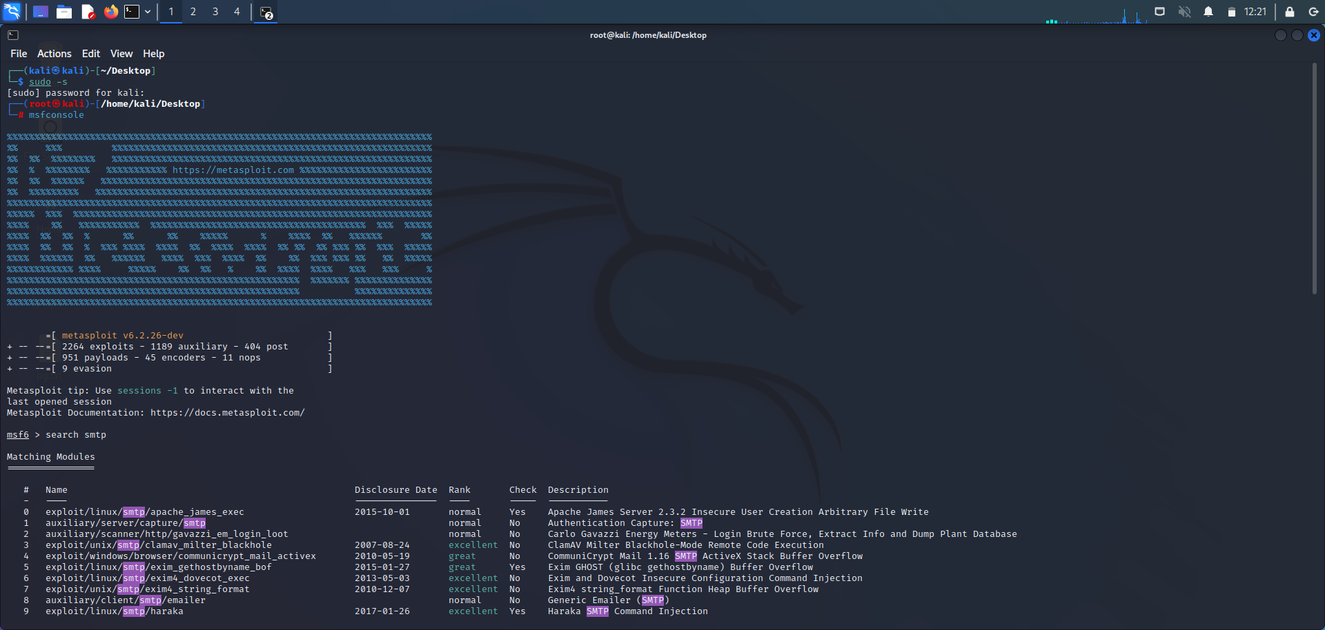

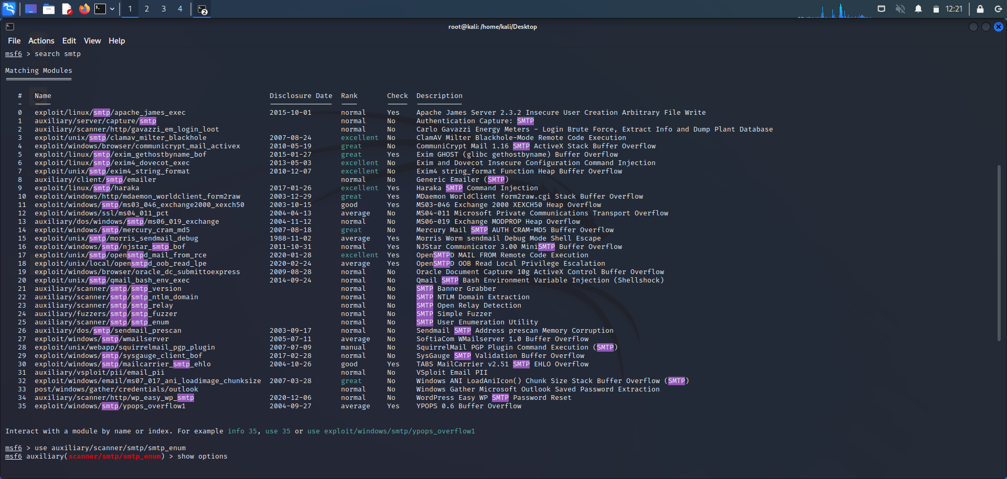

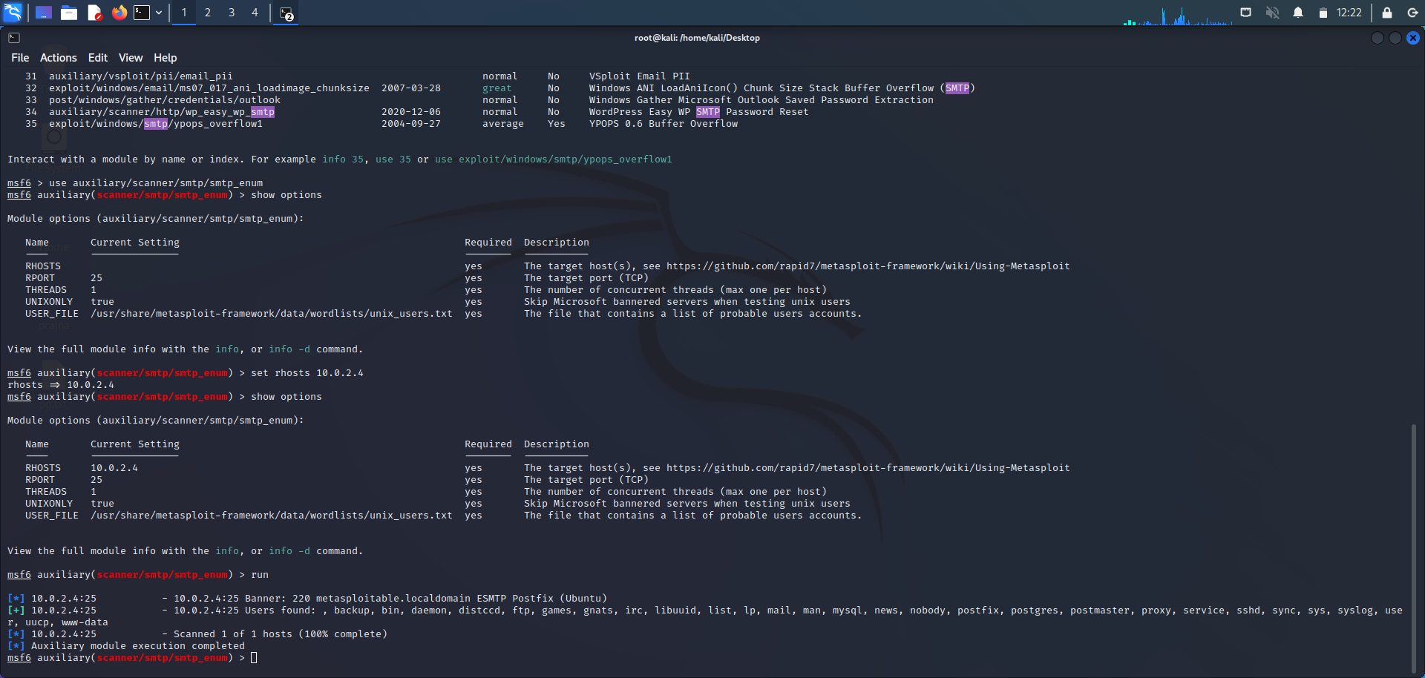

**2. BINDSHELL**

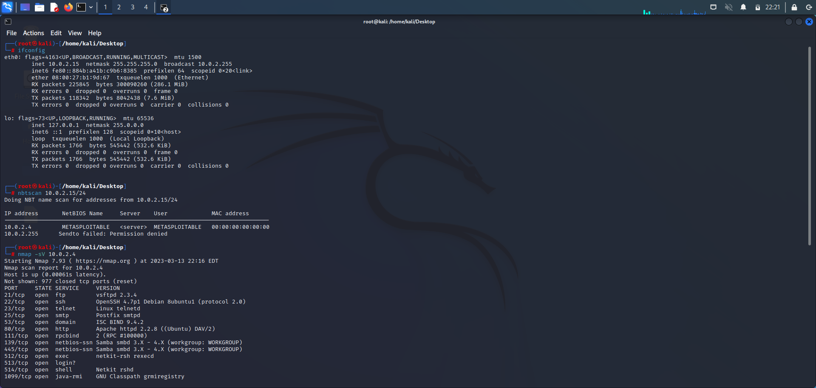

**‘ifconfig’** is used to find the IP address of the machine.

**‘nbtscan’** is a command-line tool used to scan networks for NetBIOS name information. It can be used to identify Windows machines on a network, as well as gather information such as hostnames, MAC addresses, and workgroups.

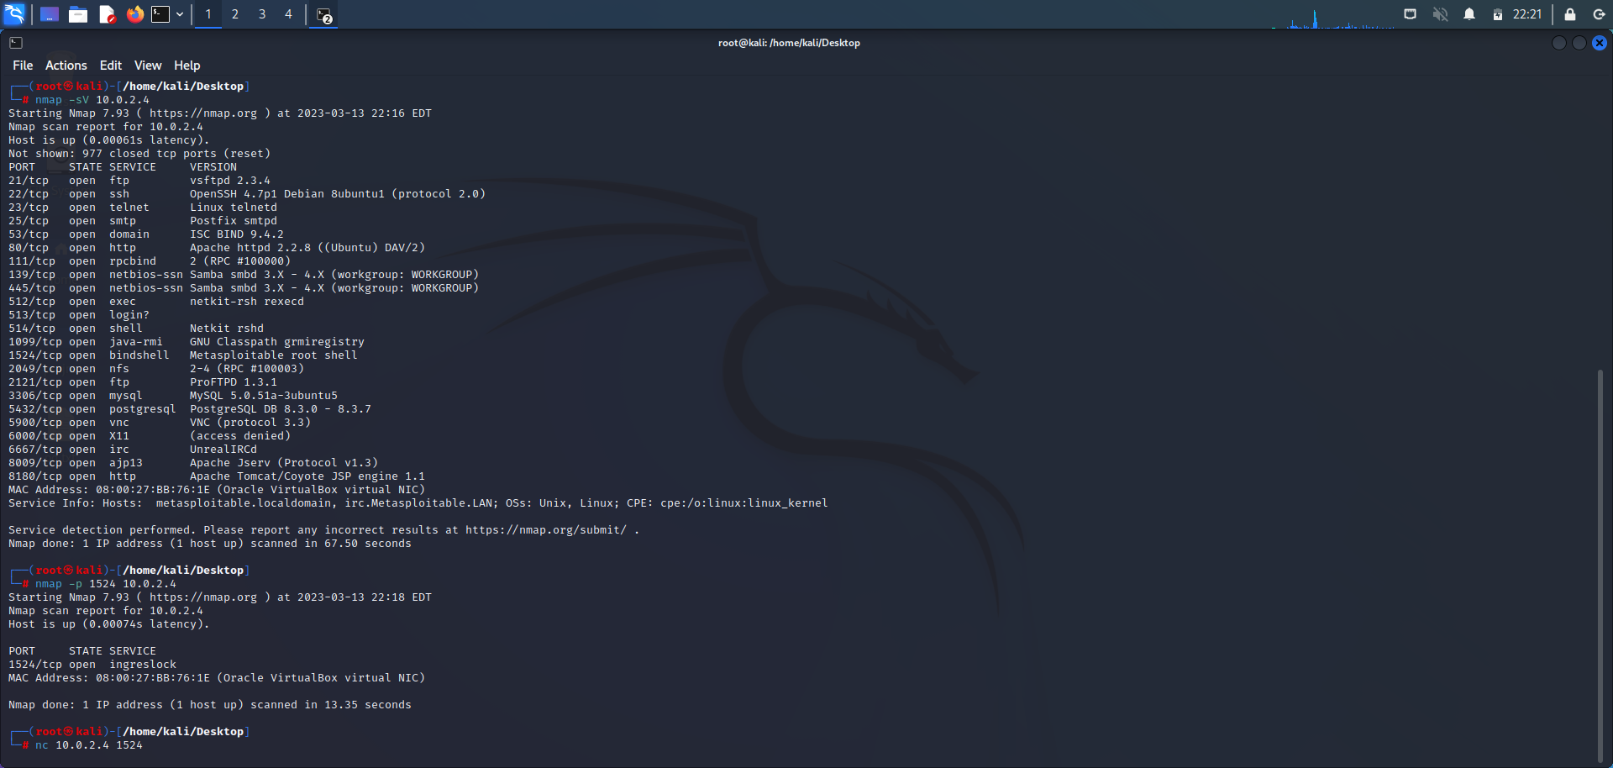

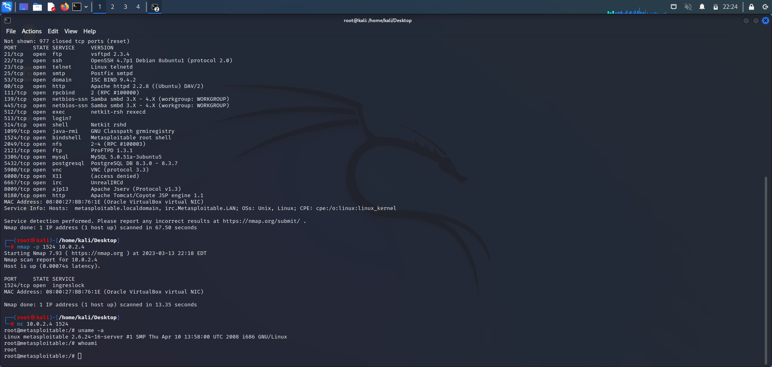

The **‘nmap -sV 192.168.56.101’** command is an example of using the Nmap security scanner tool to perform a version detection scan on the IP address **192.168.56.101**.

* **nmap**: This is the command to invoke the Nmap security scanner.
* **-sV**: This option instructs Nmap to perform version detection on any open ports found on the target system.
* **192.168.56.101**: This is the IP address of the target system that Nmap will scan.

When you run this command, Nmap will attempt to discover any open ports on the target system and identify the services running on those ports by performing a version detection scan.

The **nmap -p 1524 192.168.56.101** command is an example of using the Nmap security scanner tool to perform a port scan on the IP address **192.168.56.101**, specifically checking for the presence of an open port with port number 1524.

* **nmap**: This is the command to invoke the Nmap security scanner.
* **-p 1524**: This option instructs Nmap to scan only port 1524 on the target system.
* **192.168.56.101**: This is the IP address of the target system that Nmap will scan.

When you run this command, Nmap will attempt to discover whether the port number 1524 is open on the target system. If the port is open, Nmap will report it as an open port, along with any additional information about the service running on that port. This type of scan is useful for determining which ports are open on a system and can help in identifying potential vulnerabilities or weaknesses that may exist.

* **nc**: This is the command to invoke the **nc** (short for netcat) tool.
* **192.168.56.101**: This is the IP address of the target system to which you want to connect.

When you run this command, **nc** will attempt to establish a connection to the target system. If the connection is successful, **nc** will open a command-line interface where you can send and receive data to and from the remote system.

* **uname**: This is the command to invoke the **uname** tool.
* **-a**: This option instructs **uname** to display all available information about the system

When you run this command, uname will output a series of system information, including:

* Linux: This is the kernel name of the system.
* hostname: This is the name of the system.
* x86_64: This is the machine hardware name.
* GNU/Linux: This is the operating system name.

**uname -a** provides a quick way to obtain detailed information about the system's kernel and operating system, which can be useful for system administration and troubleshooting purposes.

the '**whoami’** command is a simple command that is used to print the username of the current user who is logged in to the current terminal session.

**3. FTP**

Step 1: Getting super access using the command $ sudo -s

Step 2: Enter the command nmap -sV followed by the target IP, nmap is a utility for network exploration security auditing and -sV for the system versions. nmap -sV 192.168.56.101

Step 3: Enter msfconsole, it is used to provide a command line interface to access and work with the Metaspoilt framework

Step 4: Enter the command search vstpd

Step 5: Enter the command exploit/unix/ftp/vstpd_234_backdoor which is available from step 4 use exploit/unix/ftp/vstpd_234_backdoor

Step 6: Payload is not configured. Just enter show options

Step 7: In the option we must set the value for RHOSTS so enter the command set RHOSTS followed by the IP of the target, set RHOSTS 192.168.56.101

Step 8: We use show options in-order to check whether the RHOSTS has been updated or not.

Step 9: Enter the command show payloads

Step 10: We must set the payload as set payloads 192.168.56.101

Step 11: Enter the command exploit

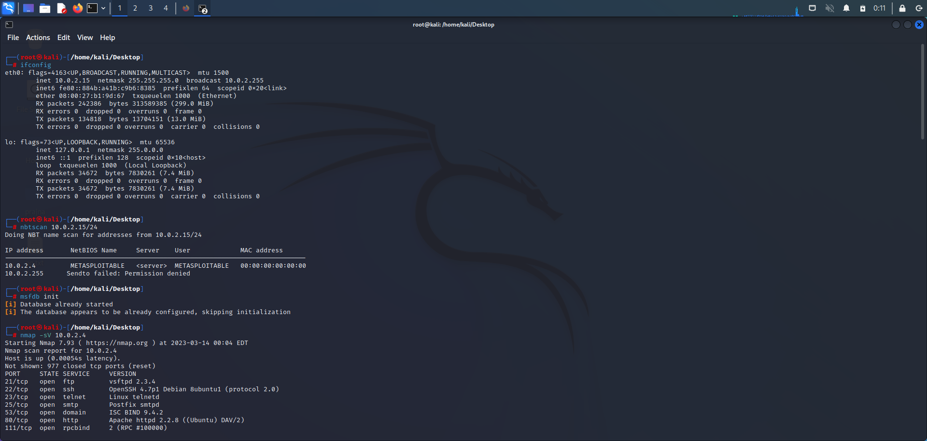

**‘ifconfig’** is used to find the IP address of the machine.

**‘nbtscan’** is a command-line tool used to scan networks for NetBIOS name information. It can be used to identify Windows machines on a network, as well as gather information such as hostnames, MAC addresses, and workgroups.

The **msfdb init** command initializes the Metasploit Framework's database. Metasploit Framework is a tool used for penetration testing, vulnerability assessment, and exploit development.

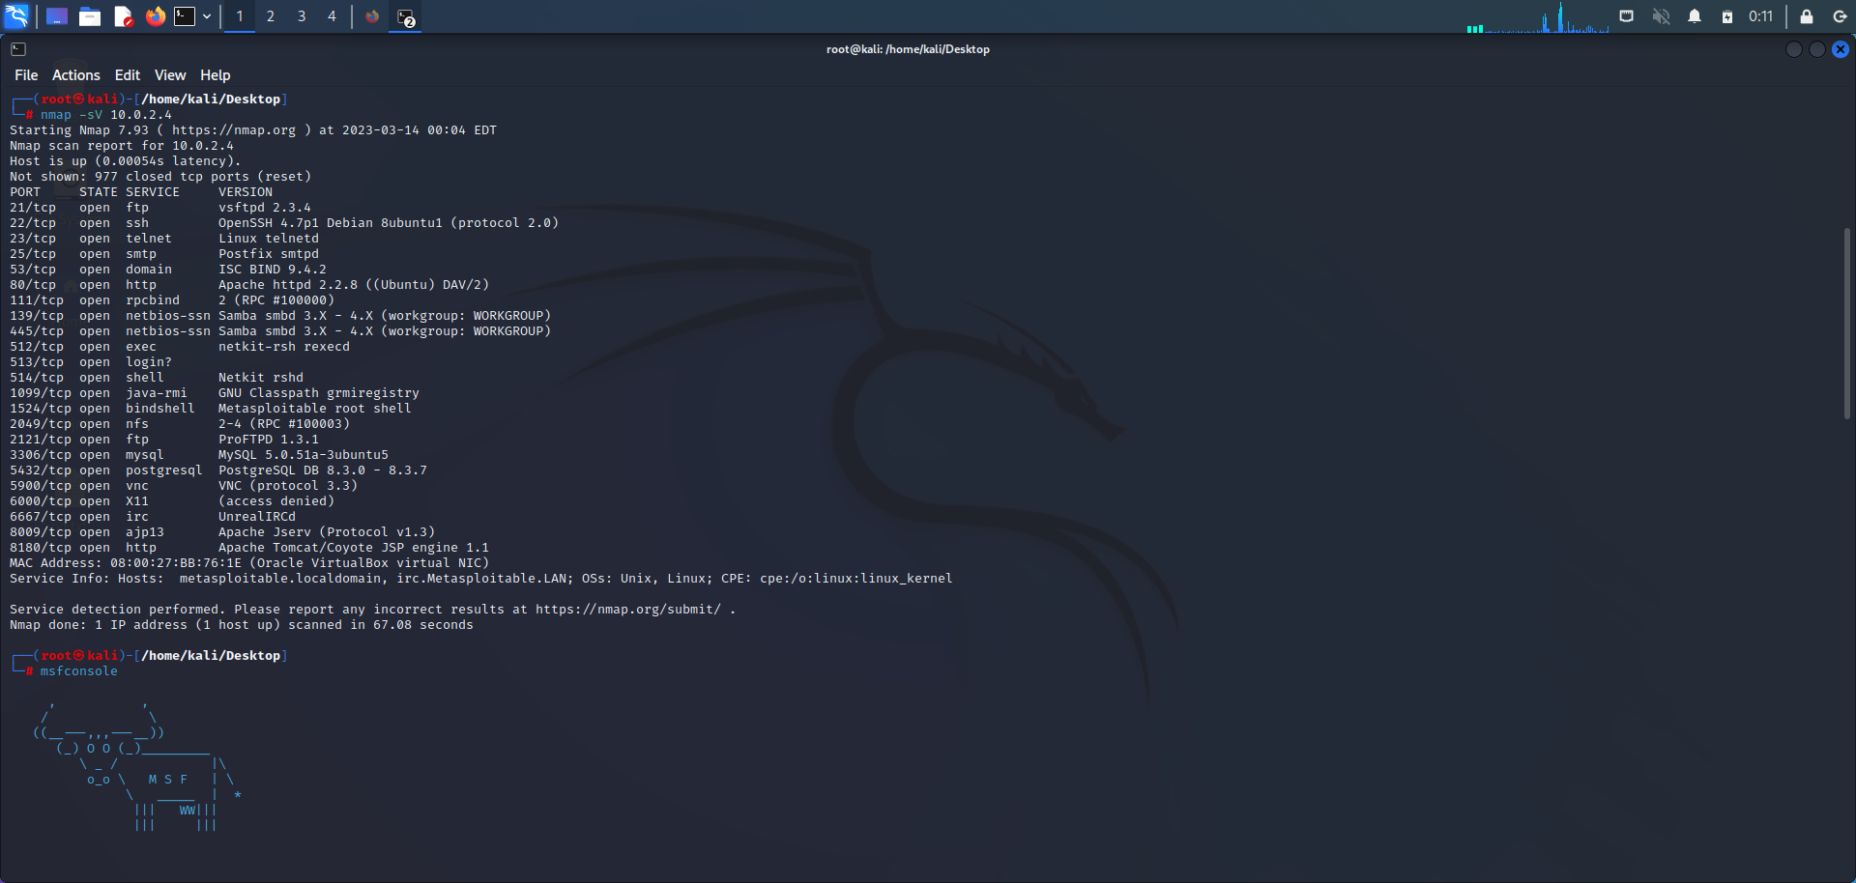

The **‘nmap -sV 192.168.56.101’** command is an example of using the Nmap security scanner tool to perform a version detection scan on the IP address **192.168.56.101**.

* **nmap**: This is the command to invoke the Nmap security scanner.
* **-sV**: This option instructs Nmap to perform version detection on any open ports found on the target system.
* **192.168.56.101**: This is the IP address of the target system that Nmap will scan.

When you run this command, Nmap will attempt to discover any open ports on the target system and identify the services running on those ports by performing a version detection scan.

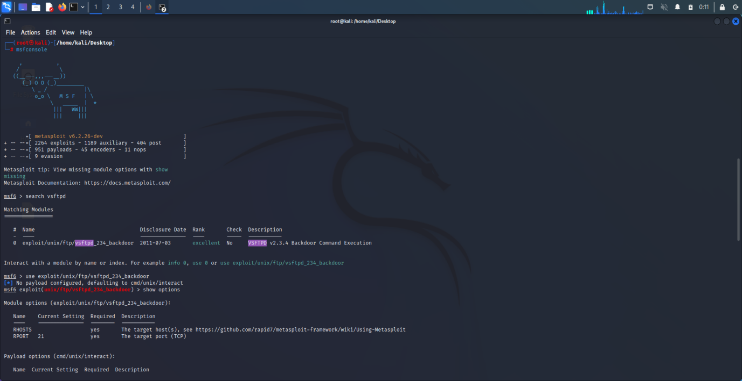

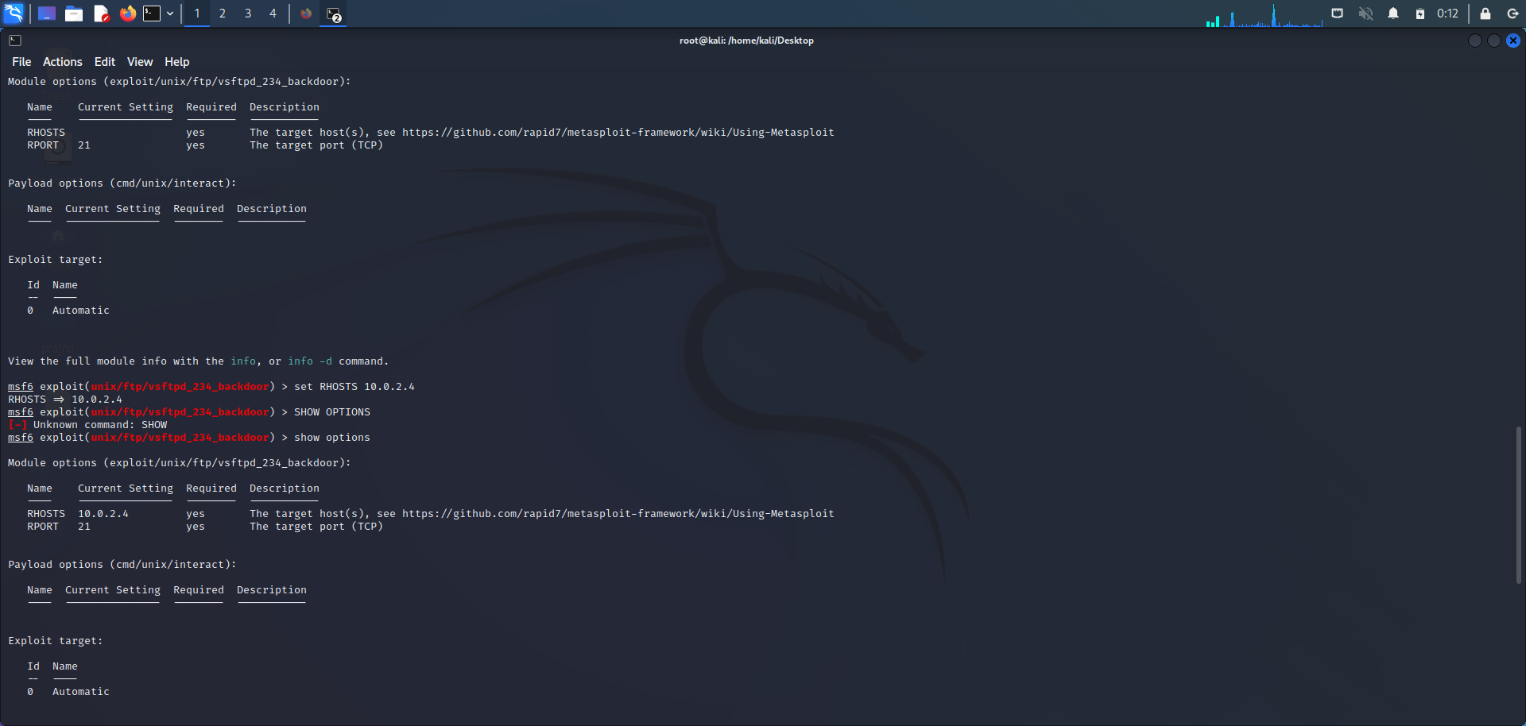

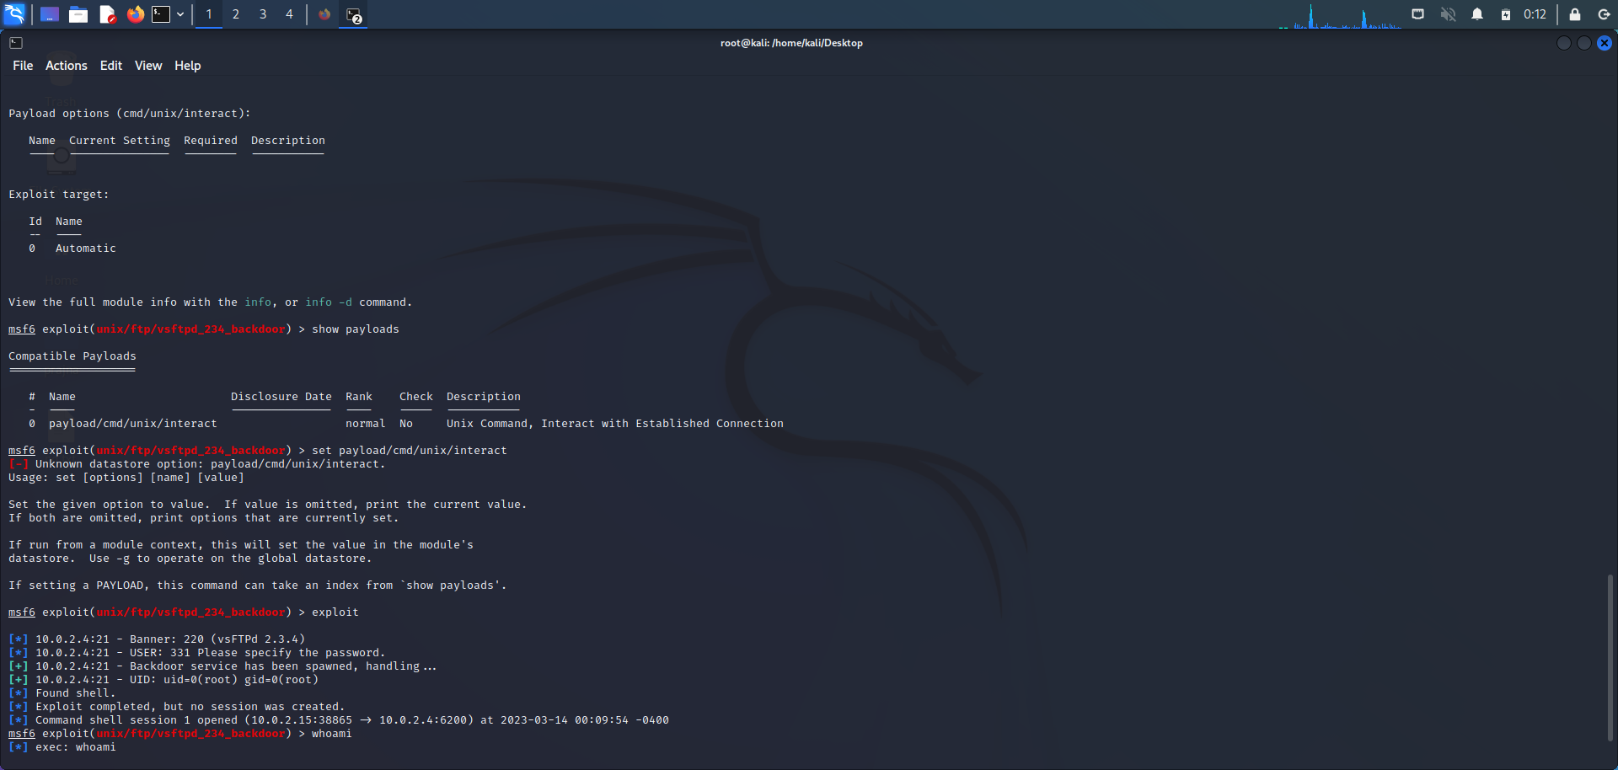

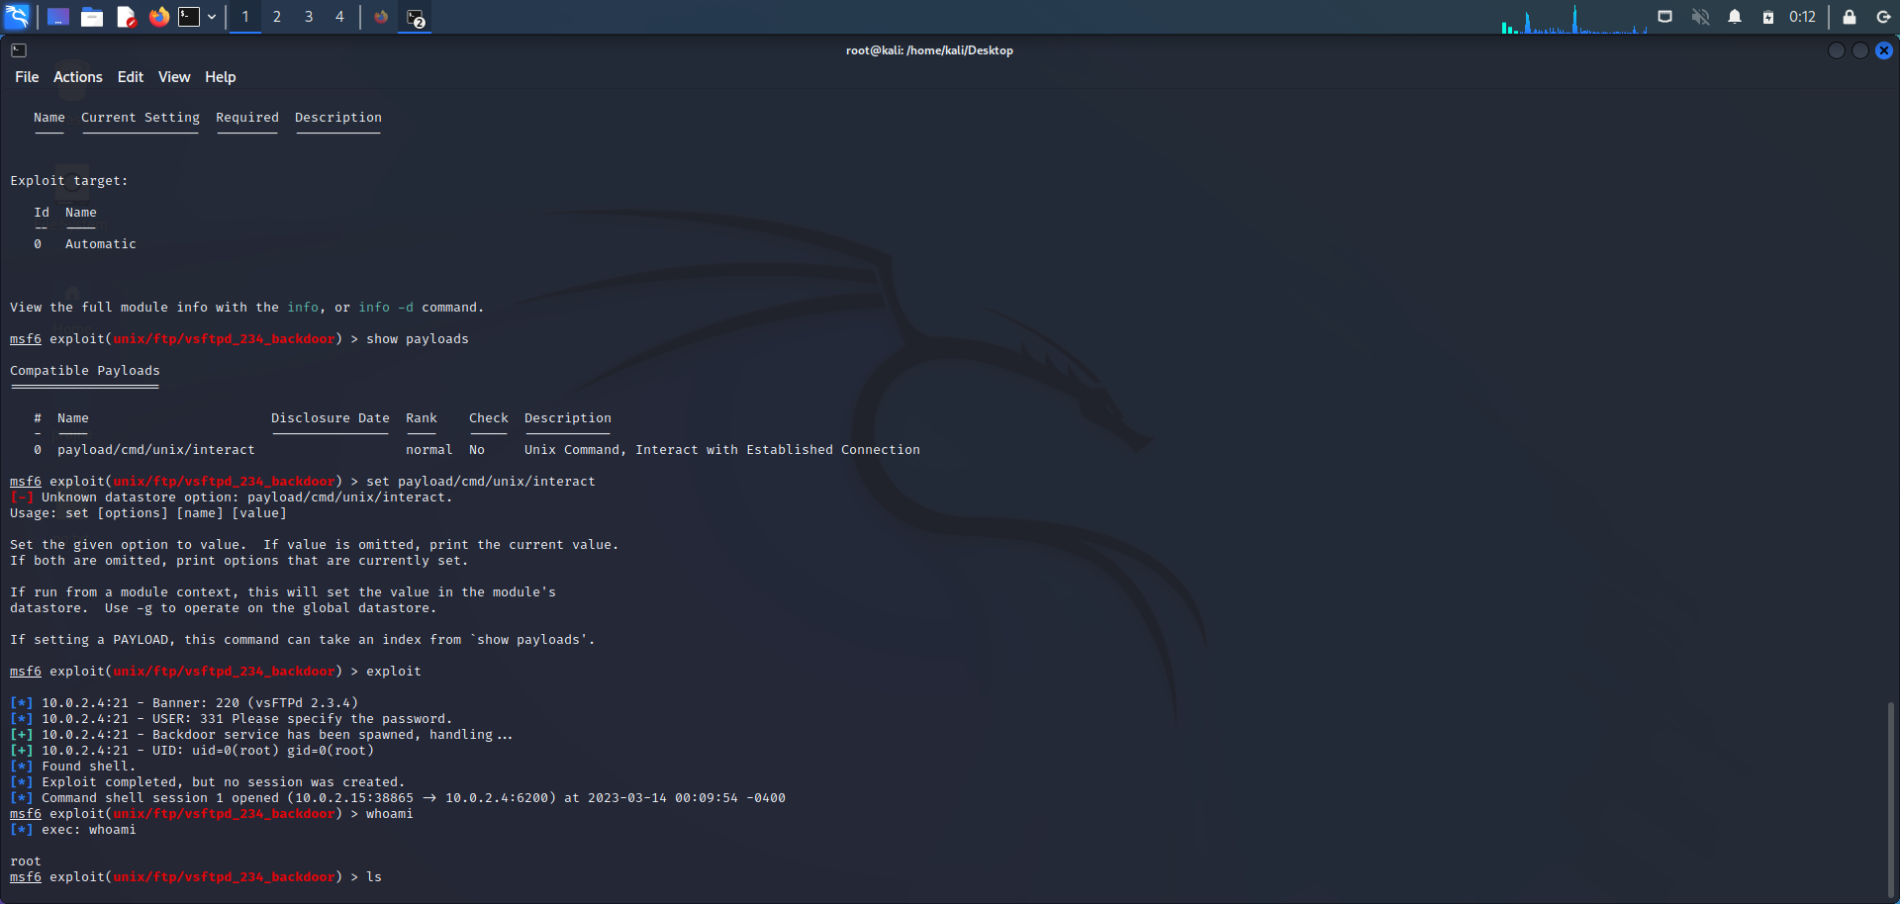

**NETWORK SCANNING**

Nmap is the most famous reconnaissance tool among Pentesters and Hacker. It is essentially a port scanner that helps you scan networks and identify various ports and services available in the network, besides also providing further information on targets, including reverse DNS names, operating system guesses, device types, and MAC addresses.

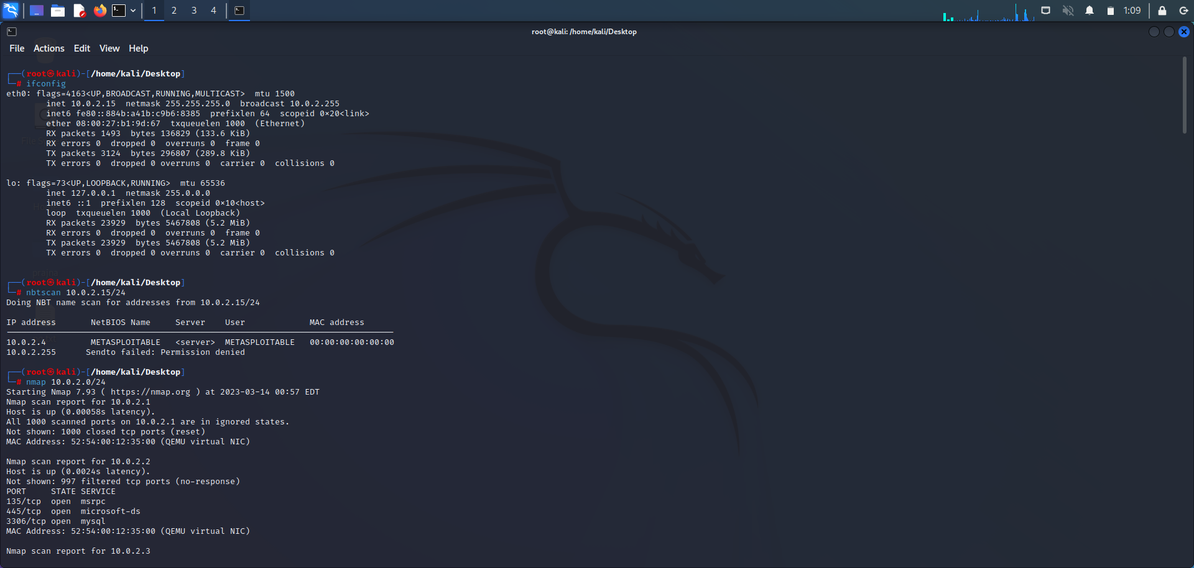

* -sV: Probe open ports to determine service/version info
* -O: Enable OS detection
* -A: Enables “aggressive” scanning. Presently this enables OS detection (-O), version scanning (-sV), script scanning (-sC) and traceroute (–traceroute)
* -p: Specify the ports to scan. It can be a single port as well as a range of ports.
* -sT:In this type of scan, Nmap sends a [TCP packet](https://www.digitalocean.com/community/tutorials/difference-between-tcp-and-udp-protocols) to a port with the SYN flag set.

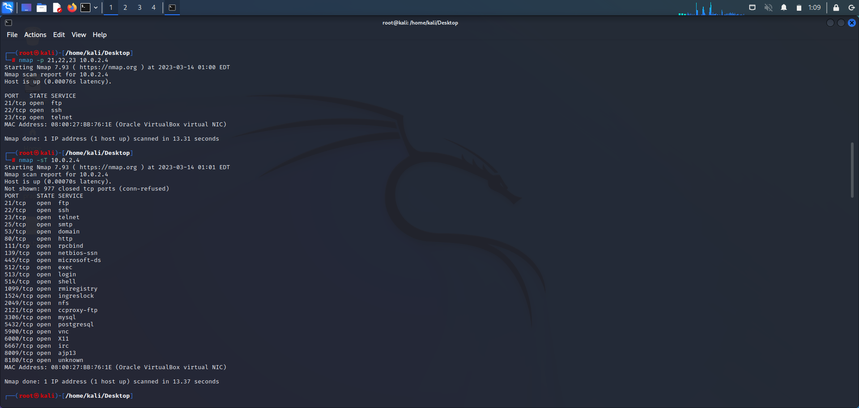

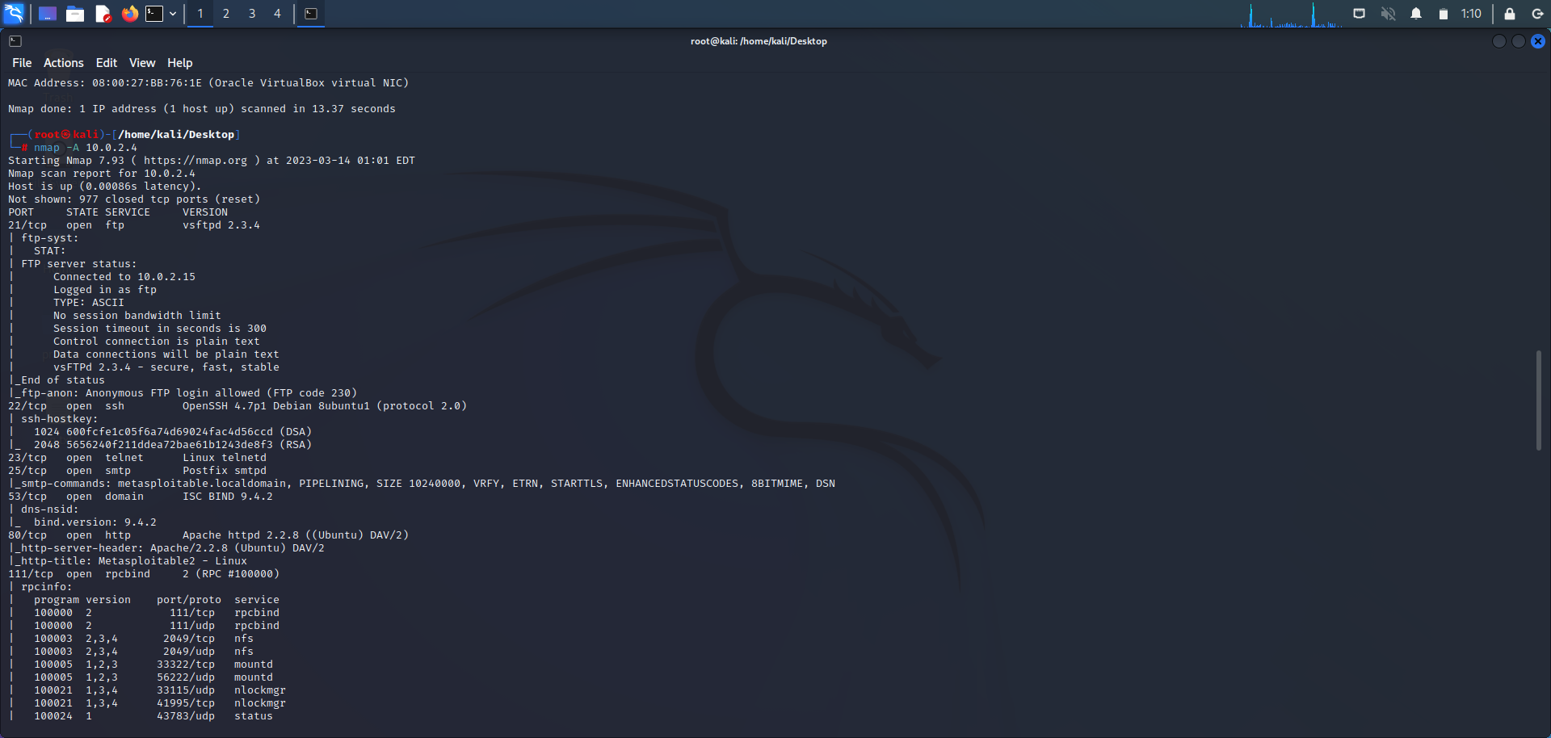

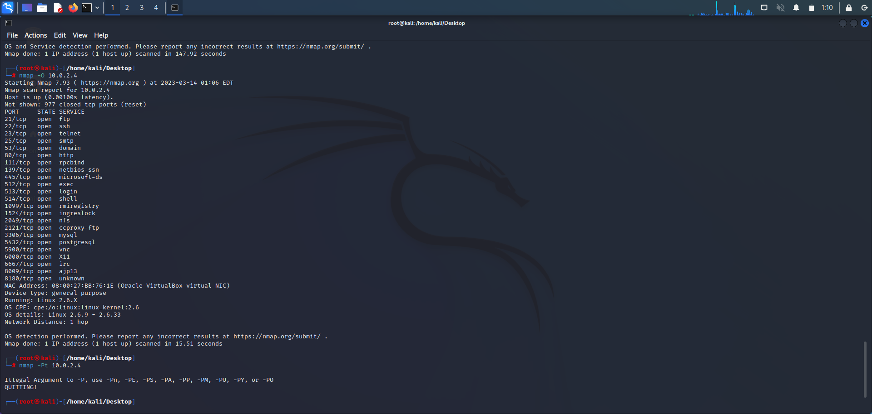

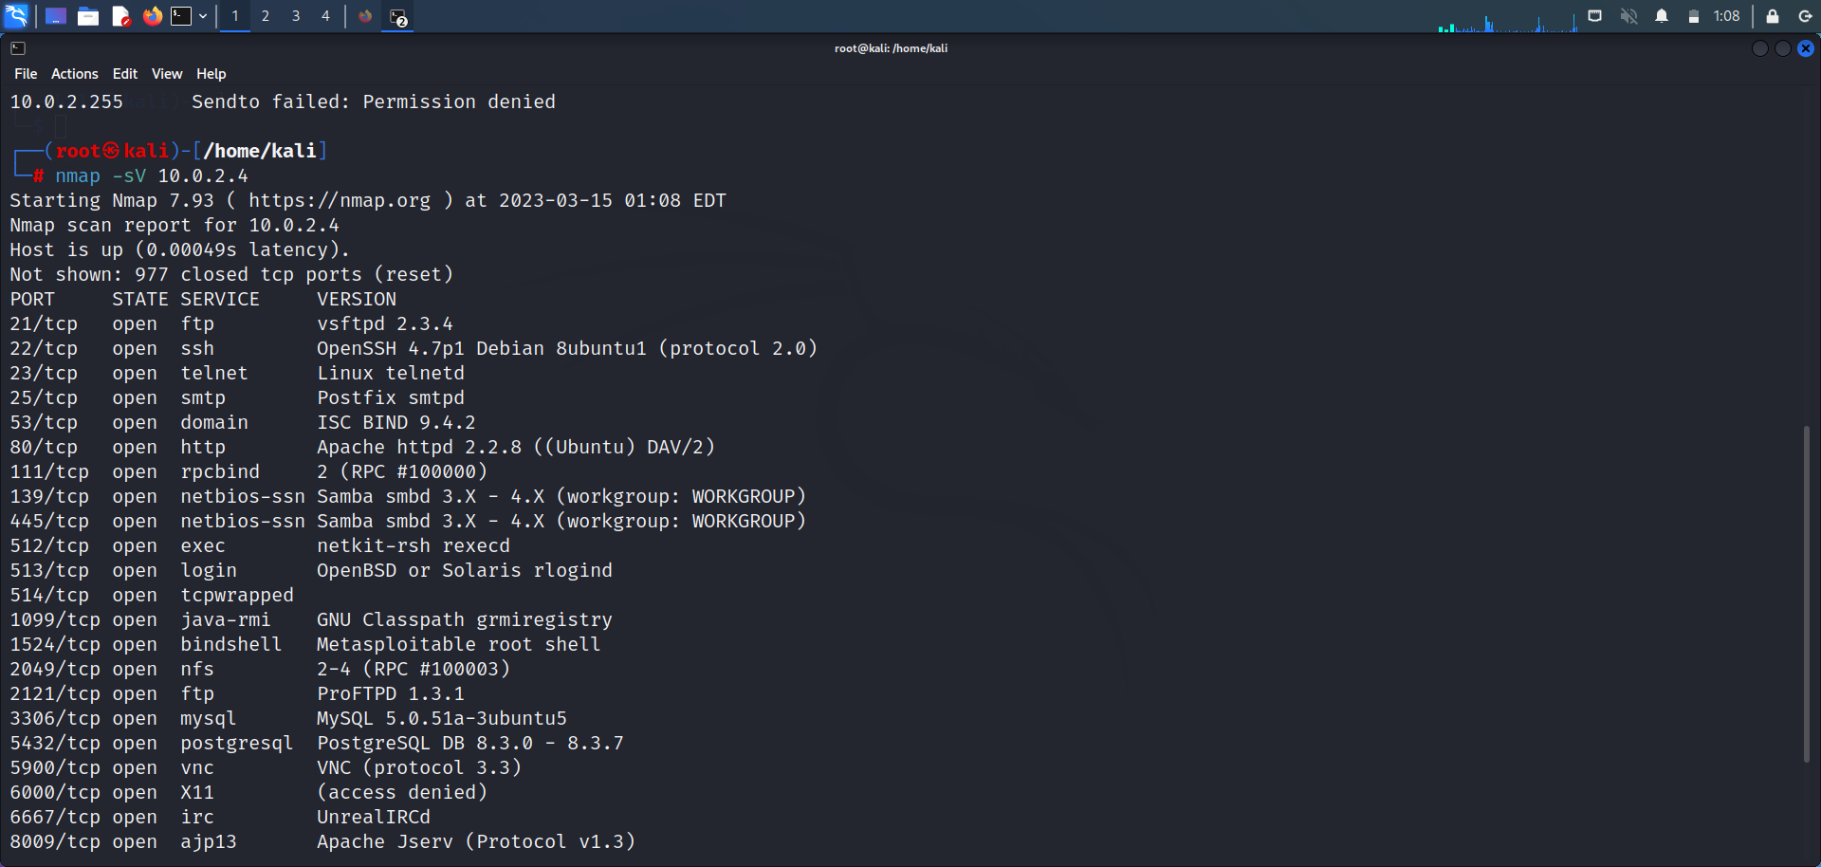

**FIRE EXTINGUISHER USING CISCO PACKET TRACER**

Fire Extinguisher project is done using the cisco packet tracer. Cisco packet tracer is a network simulation tool . This project is used to control the fire and to activate the sprinkler when there is smoke detected beyond the range specified.

To implement this we required mainly 4 components the are a server, water sprinkler, smoke detector , and 3 cars that emits the smoke.

**STEPS:**

• Drag and Drop Server pt,Access point,Smoke detector,lawn sprinkler sprinkler,old car-3.

• Rename Server pt as *"Registration Server"* and Rename lawn sprinkler sprinkler as "*lawn sprinkler IOT-0".*

• Double click on Access point and select config then select port1 and write *"SSIO"* inplace of CISCO .

• Double click on server and select desktop then select IP config then select *"static"* & also write IPv4 as *"1.0.0.1"*• Double click on Smoke detector and select config then select wireless0 and write *"SSIO"* inplace of CISCO & also select IP config as *"static"* and IPV4 as *"1.0.0.2"*.

• Double click on Sprinkler and select config then select wireless0 and write *"SSIO"* inplace of CISCO & also select IP config as *"static"* and IPV4 as *"1.0.0.3"*

• Now connect access point to registration server using symbol

• Double click on Sprinkler and select settings and then select Remote Server and write server address as *"1.0.0.1"* ,username:"*admin"* & password :"*admin"*and press *connect*.

• Double click on Smokedetector and select config and then select settings and then select Remote Server and write server address as *"1.0.0.1"* , username : "*admin"* & password :"*admin"* and press *connect*.

• Add IPaddress for Registration Server as *"1.0.0.1"*,Smoke detector as *"1.0.0.2"* & Lawn sprinkler IOT-0 as*"1.0.0.3"* .• Now double click on Registration server and select services

and select IOT and select *"on"*.

• Now double click on Registration server and select Desktop

and select web browser and in url type as *"1.0.0.1"* and press go.

• Now select *"signup"* and type username & password as "*admin" then press create.*

• Select *"conditions"* and select add and type name as *"smoke*

*on"* and then set the level as *">=0.4"* and select sprinkler

status *"true"* and then press ok.

• Select *"conditions"* and select add and type name as *"smoke*

*off"* and then set the level as *"<=0.4"* and select sprinkler

status *"false"* and then press ok.

• Now done with establishing connection . To obtain the smoke press ALT+car.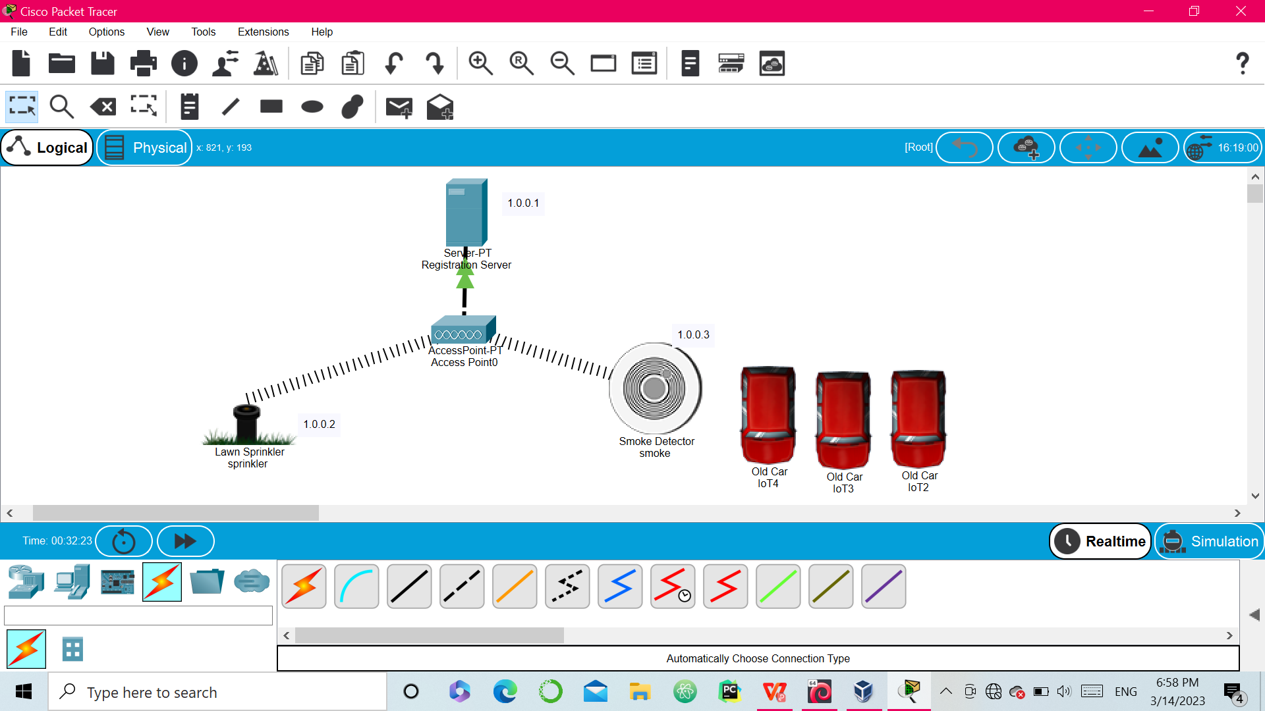.

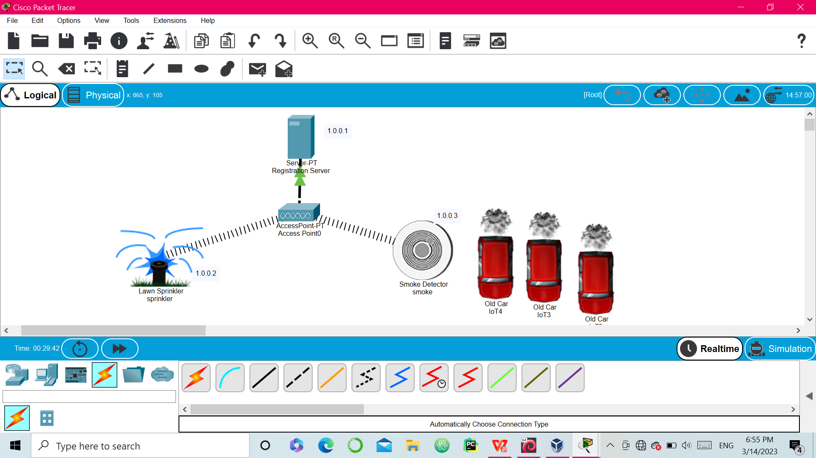

….……………………

….…………………..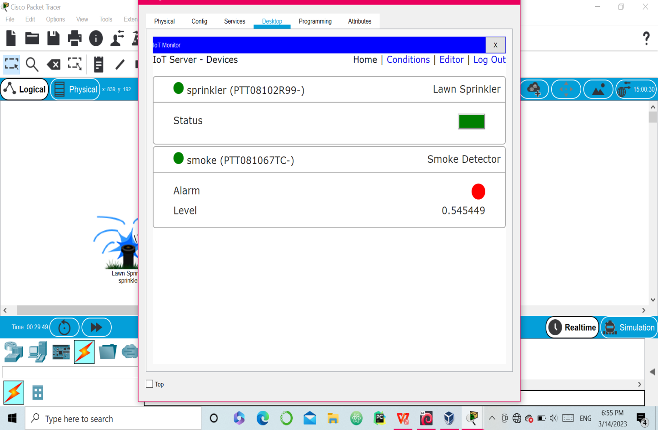

**EXPLOITING DVWA**

DVWA(Damn Vulnerable Web Application) is a PHP/MySQL web application, whose main goal is to be an aid for security professionals to test their skills and tools in a legal environment.

Step 1: Find the ip address of the pc using- ifconfig. Then find ip of Metasploit using - nbtscan.



Step 2:Copy the ip of Metasploit and paste it in firefox. Choose the DVWA in order to find the vulnerabilities .

Enter the username and password –

(i.e. username: admin ,password: password)

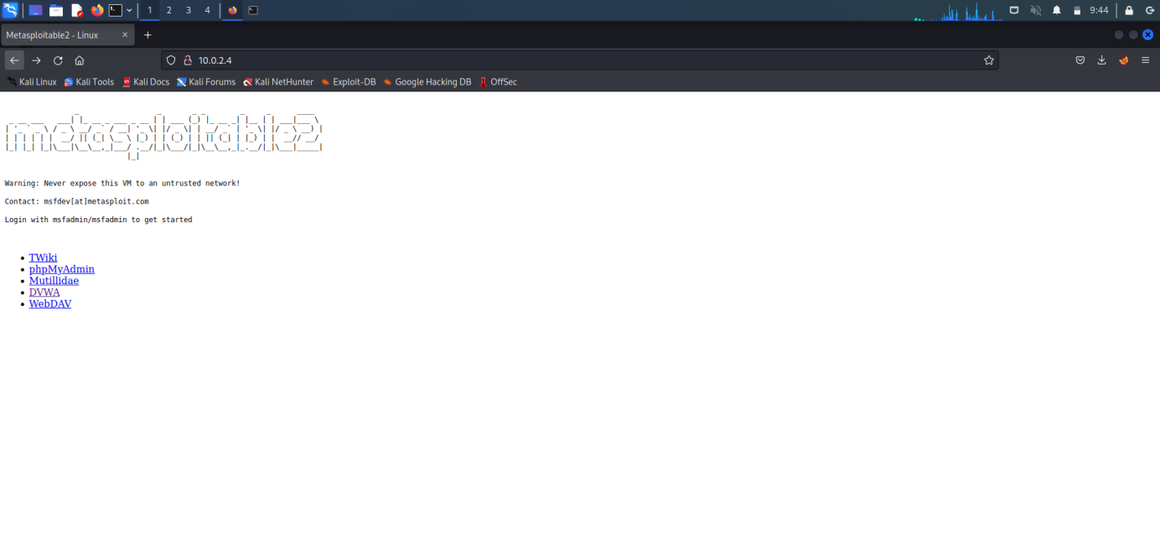

Step 3: Set the DVWA security to low.

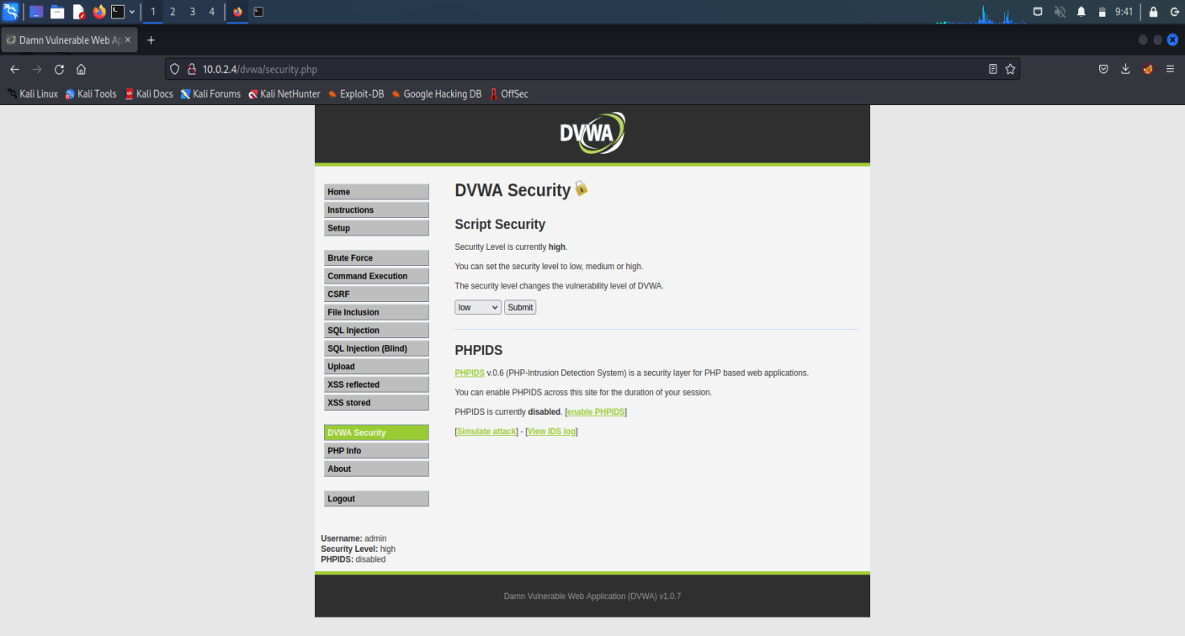

Step 4: SQL Injection – Process by passing the queries, so that we can get unauthorized access.

Step 5: SQL Injection (Blind)- also a kind of SQL injection used to attack data- driven applications using SQL statements.

SQL statements are inserted into an entry field for execution.

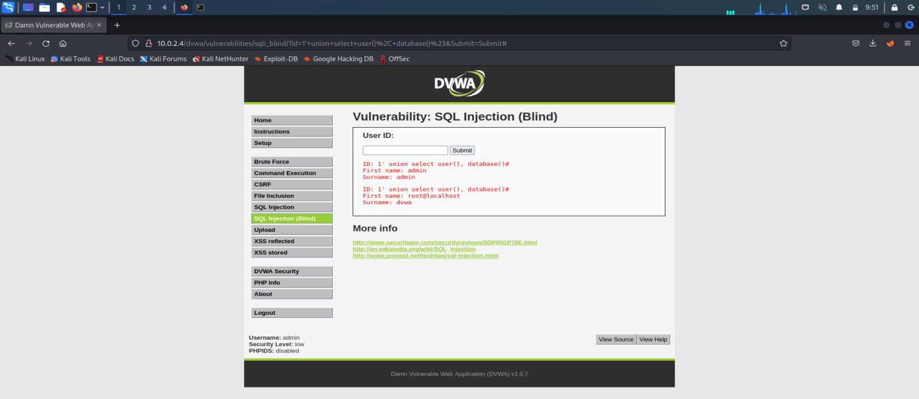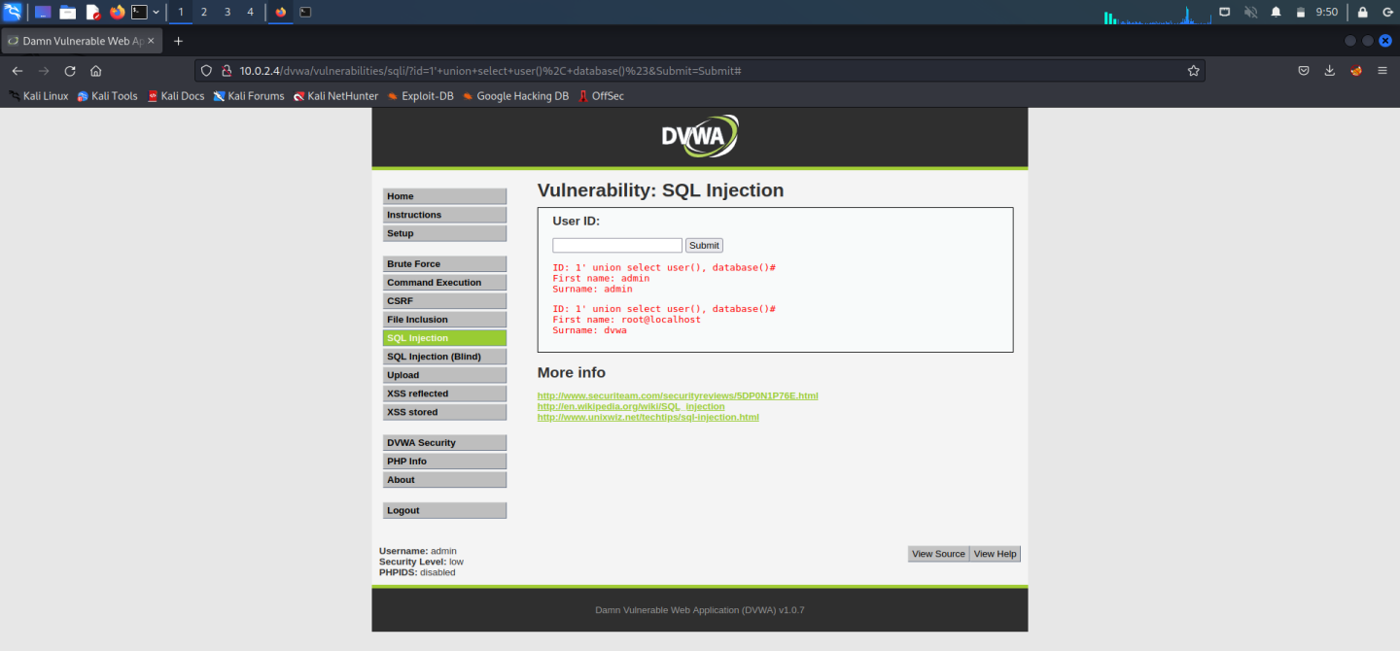

Step 6: XSS reflected- This is used to add the script. <script>alert(“device hacked”) </script>.This change will be for temporary period of time.

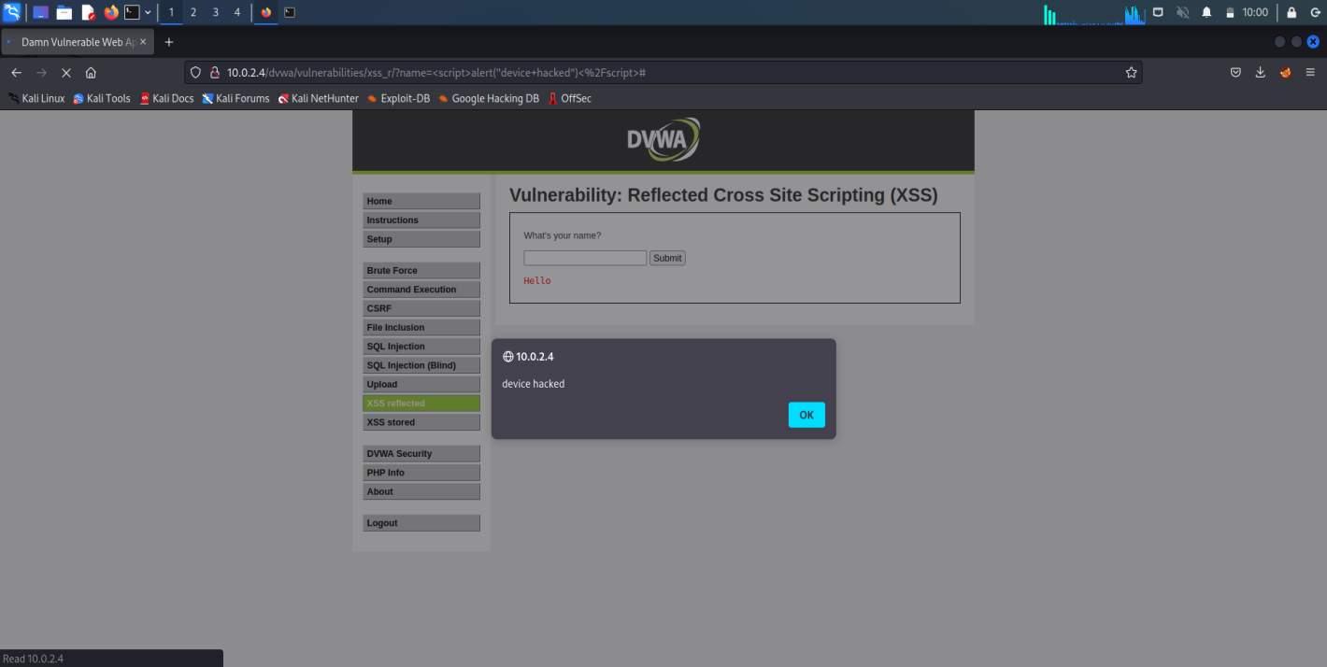

Step 7: XSS stored - This is used to add the script, but the effect here is permanent.

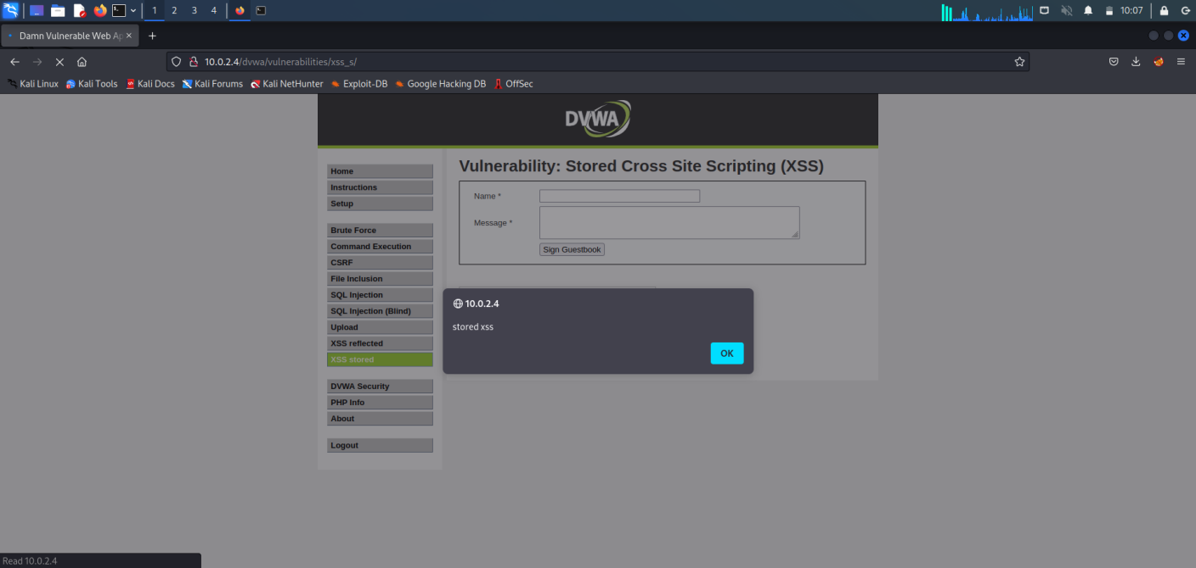

Step 8: To check the vulnerability in the upload , we can upload any files that cause damage or hacking.

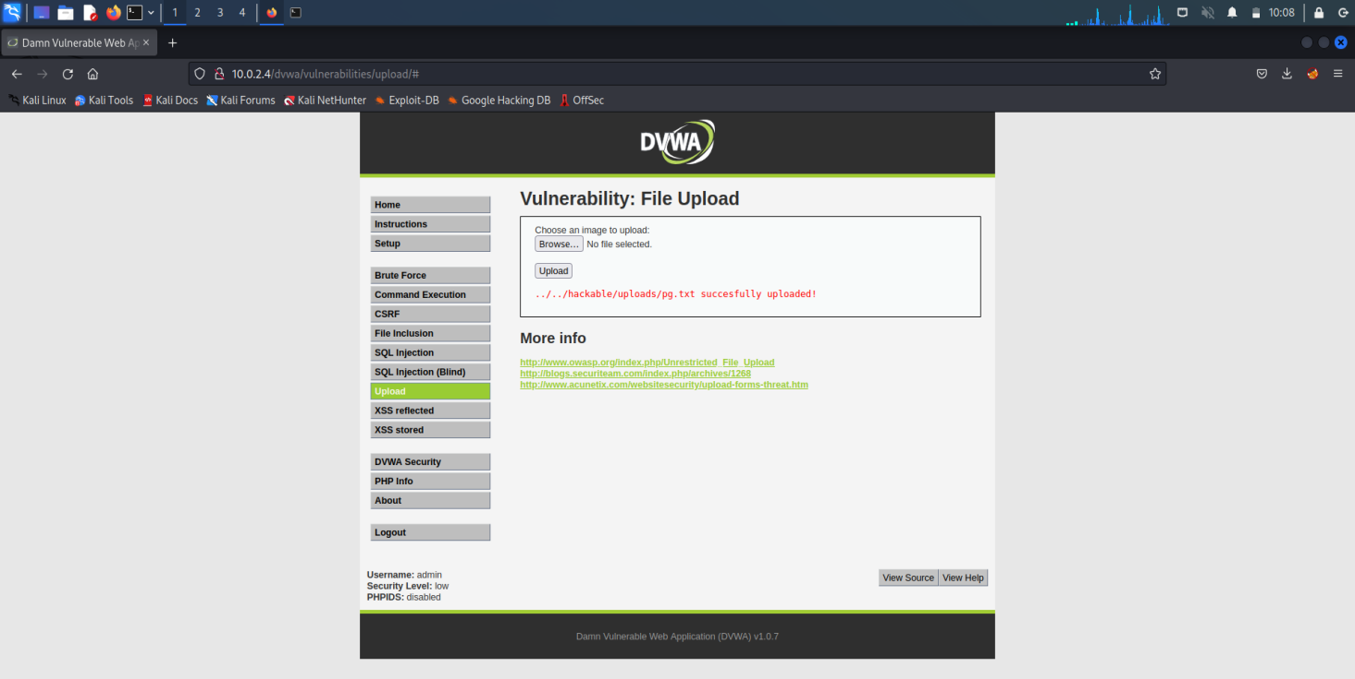

**SNIFFING USING WIRESHARK**

Wireshark is a free open source tool that analyzes network traffic in real-time for Windows, Mac, Unix, and Linux systems. It captures data packets passing through a network interface (such as Ethernet,  LAN, or SDRs) and translates that data into valuable information for IT professionals and cybersecurity teams.

Wireshark is a type of packet sniffer (also known as a network protocol analyzer, protocol analyzer, and network analyzer). Packet sniffers intercept network traffic to understand the activity being processed and harvest useful insights.Wireshark is the most often-used packet sniffer in the world. Like any other packet sniffer, Wireshark does three things.

**Step 1:** Login to kali as root user and type Wireshark.

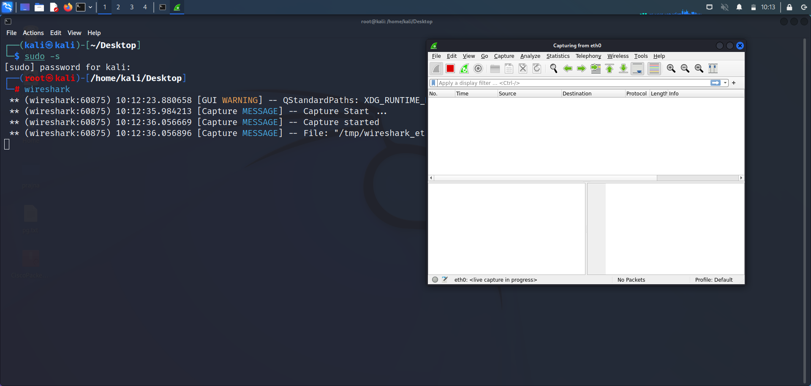

**Step 2:** Wireshark Network Analyzer will be opened and double click on **eth0**(1st option).

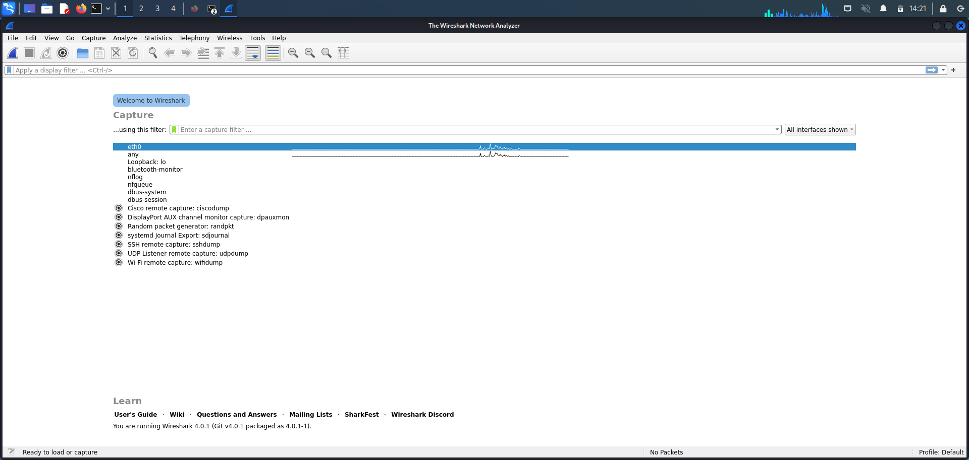

**Step 3:** Go to Firefox and search **testfire.net**

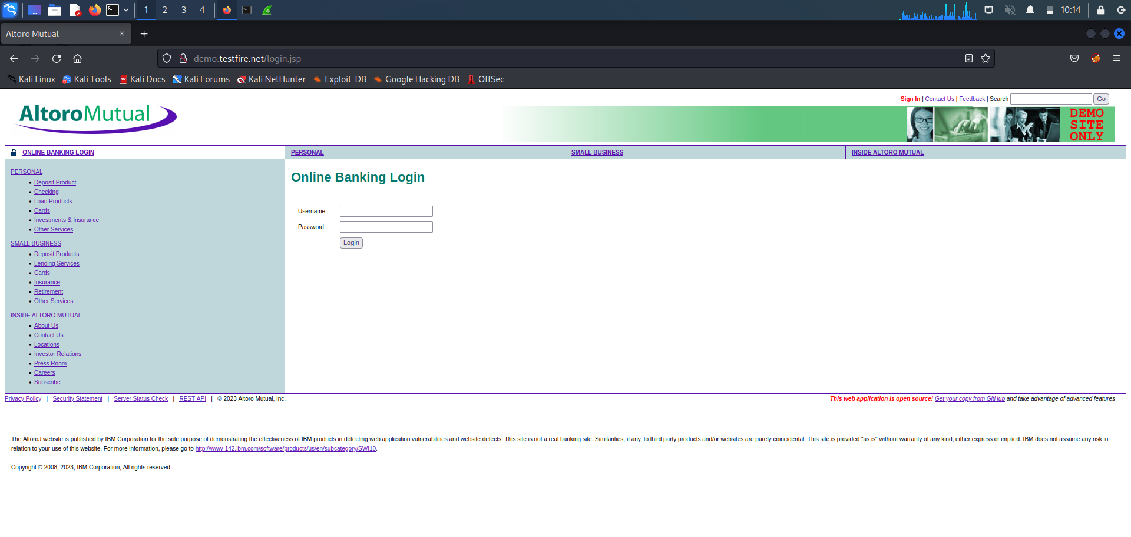

Enter Username: admin , Password: admin

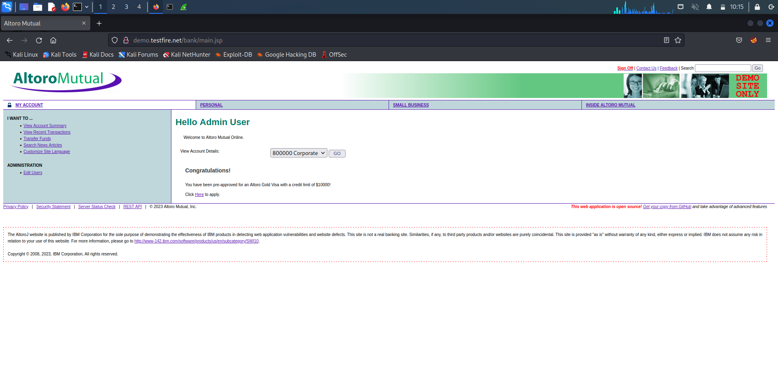

**Step 4:** Go to wire shark and in search bar filter http -post. By clicking last option, you will get the password and username to crack it.

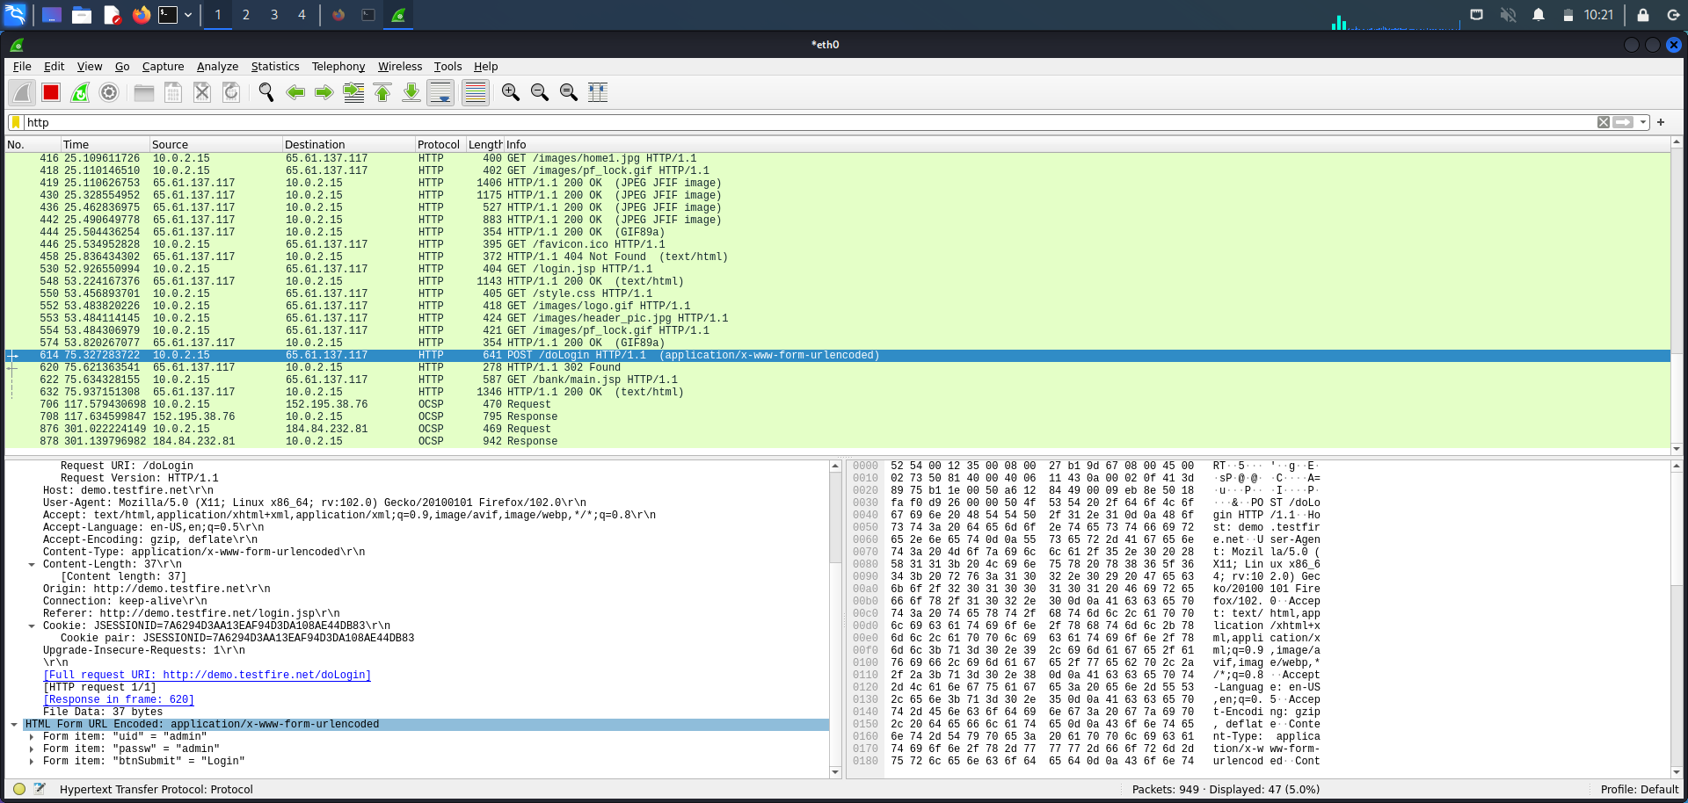

**SNIFFING USING ETTERCAP IN KALI LINUX**

Ettercap is an open-source tool that can be used to support man-in-the-middle attacks on networks. Ettercap can capture packets and then write them back onto the network. Ettercap enables the diversion and alteration of data virtually in real-time. Ettercap can also be used for the protocol analysis necessary to analyze network traffic.

Man-in-the-middle attacks place a threat actor in the middle of secure communications traffic. The primary purpose of a man-in-the-middle attack is to steal data.

**Sniffing with Ettercap:**

1. Turn on Meta, Windows 7 and kali-Linux.Login to windows and metasploitable, Transfer packets from metasploitable machine to windows 7[command: ping windowsIP]

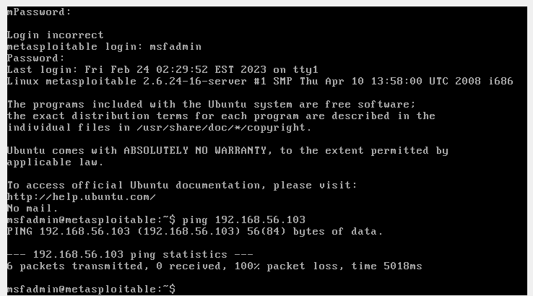

2. Access using root user [command: sudo su]

Scan the IP network for NetBIOS name information.

[nbtscan 192.168.56.102/24]

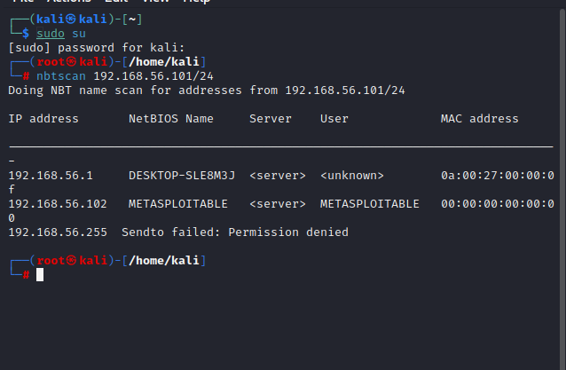

3. From Kali tools search for ettercap-graphical.

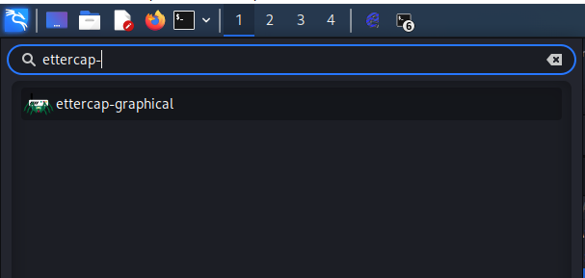

4. Enter the password as kali

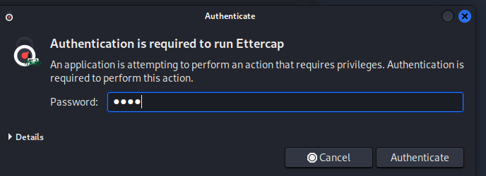

5. Select the checkbox in the below page.

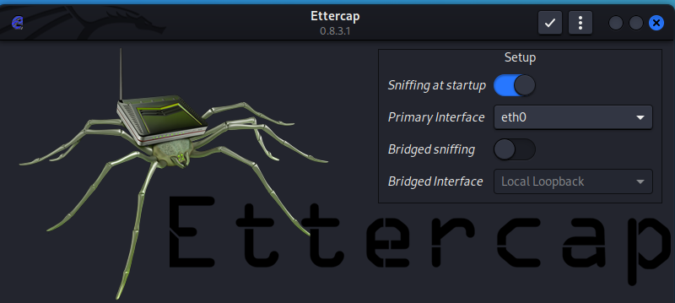

6. Select three dots in the top right corner then select hosts-> scan for the hosts from the page displayed below.

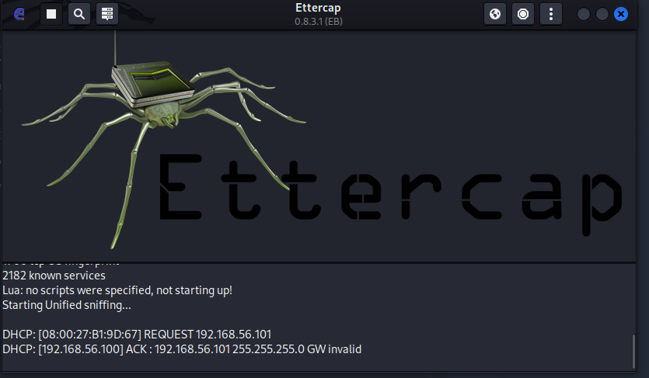

7.And then again select 3 dots ->hosts->hostlists and the below window is displayed.

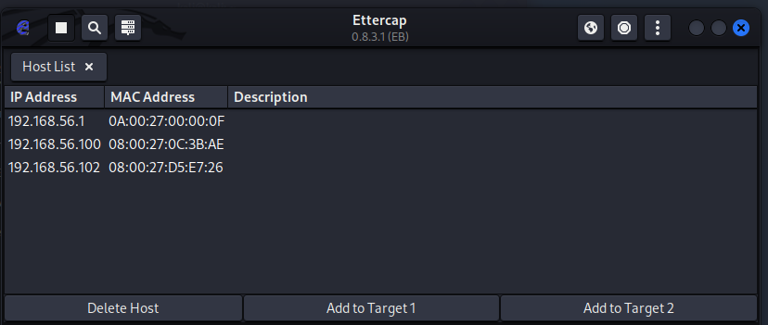

1. Select the IP network of windows7 as Add to target1 and select IP network of Metasploitable machine as Add to target2.

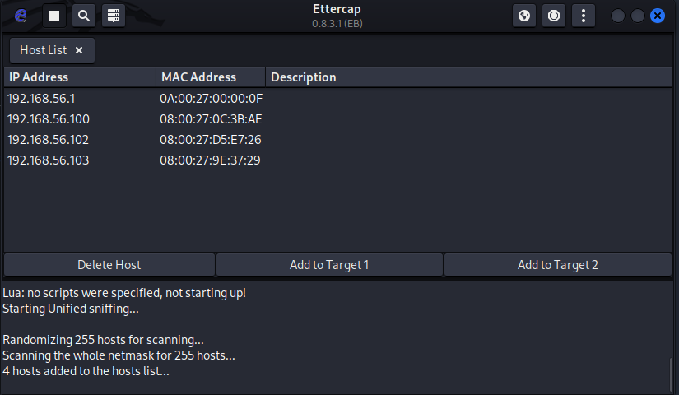

9. Below window displays that target1 and target2 has been set.

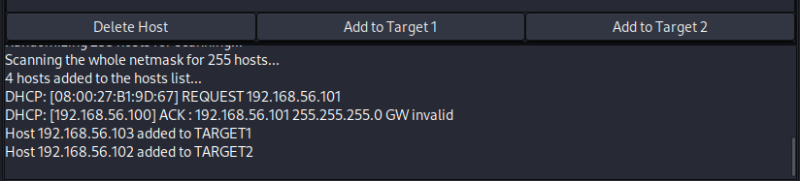

10. Select ARP poisoning from the drop down menu on clicking globe icon. In ARP poisoning attacker sends falsified ARP messages over a LAN to link an attacker’s MAC address with the IP address of a legitimate computer or server on the network.

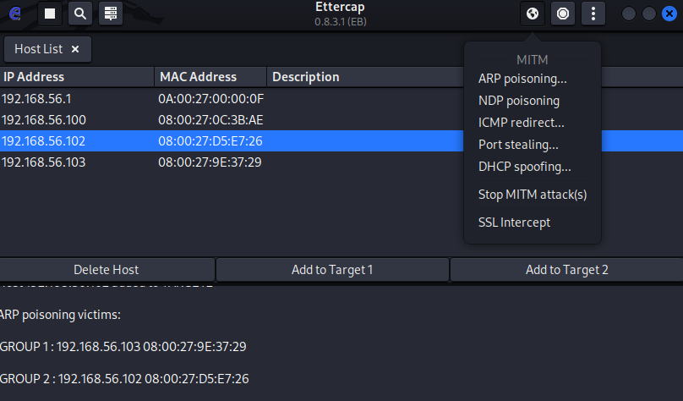

11. Open firefox in the windows 7 and browse the IP address of metasploitable machine and select DVWA option and enter the username and password to login.

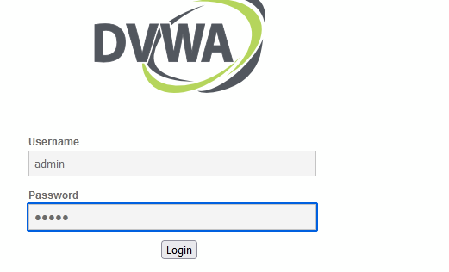

12. The entered username and password in Windows 7 will be now visible at Kali linux. By this successful sniffing between win7 and Metasploitable machines done using ettercap tool.

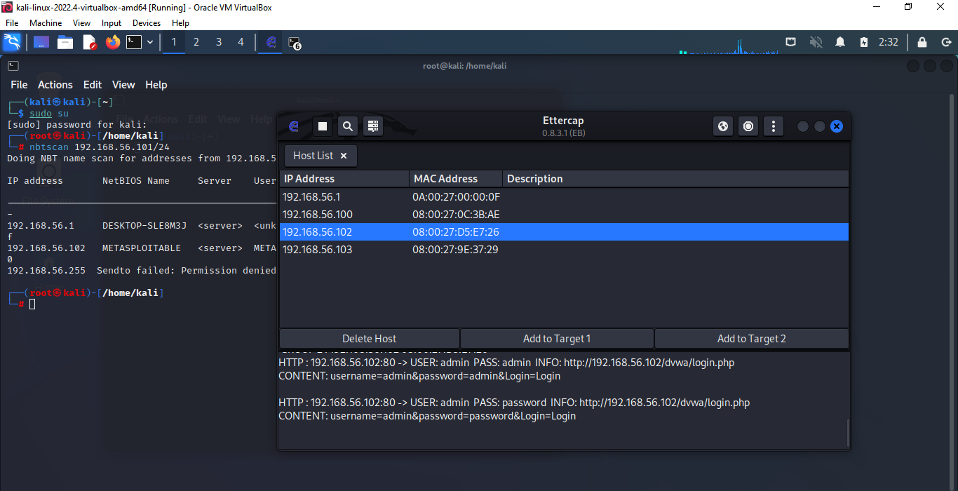

**CONCLUSION :** During our internship, we had the opportunity to delve into several concepts related to cyber security. Some of the topics we covered included password cracking of Windows 7, Metasploitable and vulnerable websites (such as testfire.net), exploiting DVWA (Damn Vulnerable Web Application) etc.Overall, the concepts we learned during this internship were highly engaging, and they motivated us to pursue further education and experience in this dynamic and critical field. In conclusion, this internship was a highly enriching experience, and we are grateful for the opportunity to learn from industry experts and to develop our skills in such an important field.